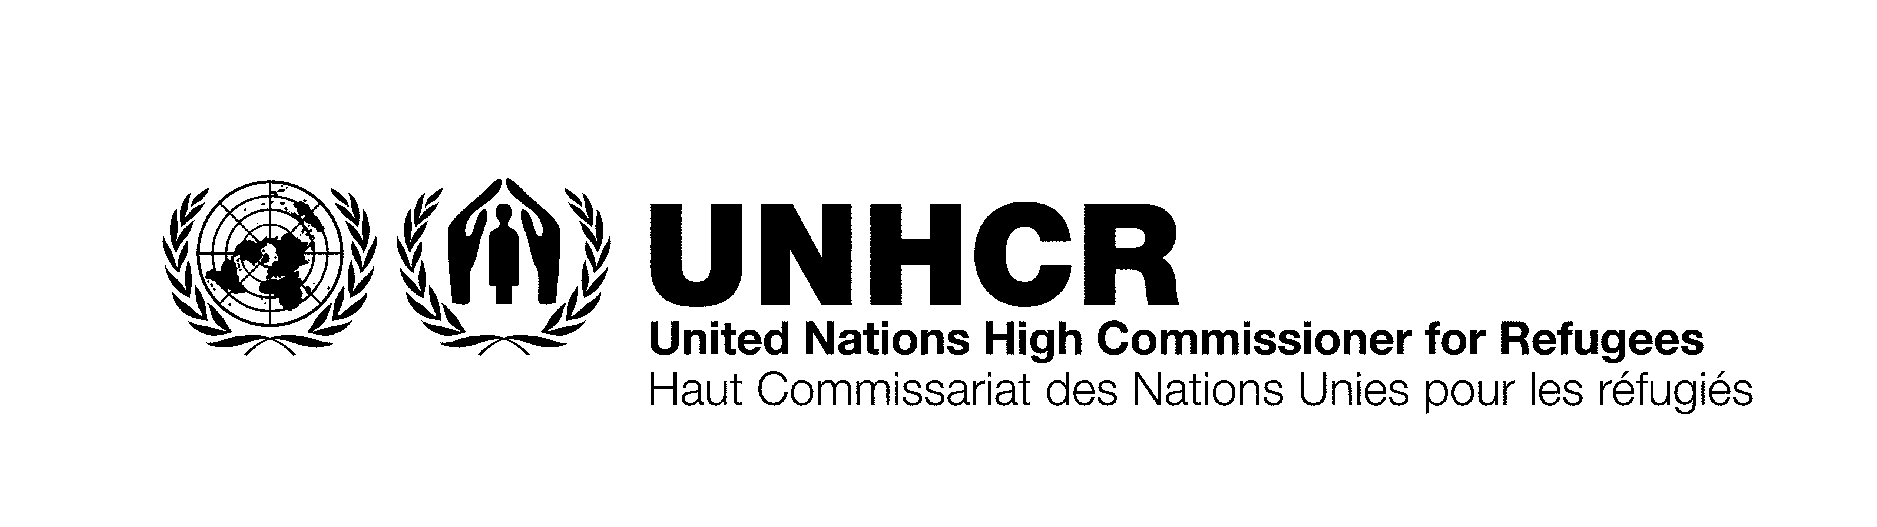

ITB No.: ITB/AZE/003/2021
SUPPLY OF DIGNITY KITS FOR UNHCR BAKU, AZERBAIJAN

Annex A
Technical Specifications

No | Item description | Unit | Qty.
1 | 1 pack of disposable menstrual pad, minimum 7 pads per box, thin, wide, single use, individually wrapped, high absorbent with wings for extra heavy flow, leak proof bottom layer, good quality non-woven tissue, cotton touch feel top sheet, not containing allergic and dangerous substances, remaining shelf life of 80%. | Each | 2,300
2 | 1 pack of disposable sanitary pads, minimum 20 pads per box, thin, with soft and cotton touch feel top sheet cover, adhesive, low absorbency level, scented, single use, individually wrapped, not containing allergic and dangerous substances, remaining shelf life of 80%. | Each | 2,300
3 | 1 Soap case holder, plastic, high quality PP material, without harmful components. Container to seal securely, with raised cushion on the bottom of the soap box to facilitate drainage and anti-sticking, all of the case components must be safe for use. | Each | 2,300
4 | 1 soap bar for washing laundry by hand, min 150g, individually wrapped, not containing mercury or any other toxic substance, not-harmful or causing allergy for hands, long durability (does not melt easily), remaining shelf life of not less than 80%. | Each | 2,300
5 | 1 hand soap bar, min 90 g, individually wrapped, good quality, hypoallergenic, scented, antibacterial, long durability (does not melt easily), remaining shelf life of 80%. | Each | 2,300
6 | 1 toothbrush, soft, adult use, strong plastic handle, medium hardness nylon bristle, individually wrapped. Bristles must be free of sharp or jagged edges and endpoints. The bristles must not fall out with normal use. All of the toothbrush components are safe for use. | Each | 2,300
7 | 1 toothpaste tube, min. 50g, concentrated paste, with fluoride, free of parabens. Fresh flavor. The toothpaste shall be free of lumps or particles which are palpable in the mouth as separates or discrete particles. The tooth paste shall not segregate, ferment or physically deteriorate during normal conditions of storage or use. The bulk of the tooth paste shall extrude from the tube in form of a continuous mass with the application of normal force. The tooth paste shall be packed in collapsible tubes or any other suitable material which shall not corrode, deteriorate or cause contamination of the tooth paste during normal conditions of storage. Remaining shelf life of 80% or 18 months, whichever is greater. | Each | 2,300
8 | 1 hand towel, 100% cotton, preferably 50x90 cm size, good quality, thick and absorbent, preferably white/blue/pink colors, fixed dye, not containing harmful or dangerous substances. | Each | 2,300
9 | 1 bath towel 100% cotton, preferably 70x140 cm size, good quality, thick and absorbent, preferably white/blue/pink colors, fixed dye, not containing harmful or dangerous substances | Each | 2,300
10 | 1 pair of socks, 100% cotton, 36-40 woman size, preferably white/light grey/pink/light blue colors, fixed dye good quality thick fabric, nontransparent, durable, skin friendly, not containing any allergic substances. | Each | 2,300
11 | 1 warm tights (one size) – thermal elastic tights lined with soft fleece / cotton, with elastic waist. Not containing any allergic substances, solid color black or dark. | Each | 2,300
12 | 1 twin blade disposable razor with caregiving sliding stripe. With fixed head on the end of a curved arm with ribbed handle for a firm grip. Each one to have a flip-off cover for added safety in storage. | Each | 2,300
13 | 1 pack of wet tissues, antibacterial, hypoallergenic skin cleaning, non-woven, soft, thick material, min. 72 pcs packaging, free of harmful chemicals including free of parabens, sulfates and dyes. | Each | 2,300
14 | 1 bottle of cleansing solution/rubbing alcohol, solution for cleaning hands, 300 gr minimum, good quality, isopropyl 70% solution, rub-in-hand antiseptic–disinfectant. | Each | 2,300
15 | Ethyl Alcohol 96˚ spray, 100 ml. | Each | 2,300
16 | 1 shampoo 3 in 1, bottle of minimum 200ml, for adults. For normal hair. Hypoallergenic, PH neutral, not harmful to human and in particular not irritating to the eyes. Pleasant fresh scent. 80% shelf life. | Each | 2,300
17 | 1 pack of laundry powder, 400g minimum per pack, for washing laundry by hand; water resistant package. Not containing mercury or any other toxic substance, not-harmful or causing allergy for hands. Remaining shelf life not less than 80%. | Each | 2,300
18 | 1 pack of 50 face masks - soft, made of standard polypropylene material, minimum 2 layers, unisex, one-size, with elastic ear loops, with flexible built-in plastic nose band. The whole pack must be wrapped in plastic packaging. | Each | 2,300
19 | 1 warm blanket – woven, minimum size 180x140 cm, lightweight, soft, breathable, machine washable, not containing harmful or dangerous substances. | Each | 2,300
20 | 1 electric kettle – 0,5 L, stainless steel / safe plastic, with water indicator and ergonomic handle, cordless kettle body, separatable base with automatic shut off and boil dry protection feature, power min 650W. | Each | 2,300
21 | 1 pouch bag with drawstring, 50x70 cm, with printed full colour logo 15x15 cm, water resistant material, washable, dust-proof, suitable to hold all the contents of the Dignity Kit. | Each | 2,300
Note:

The selected supplier will be responsible for safe transportation, loading and offloading of the goods as follow:

- 2,300 Dignity Kits to be delivered to UNHCR Warehouse at:
Baku, Azerbaijan, Gala Kombinati located in Ziya Bunyadov Avenue or any other warehouse within Baku

- 2,300 Dignity Kits to be delivered to the warehouse(s) in region(s) of Azerbaijan within 350 km distance.

The selected supplier is responsible to ensure accurate loading of Dignity Kits in the warehouses on pallets to avoid damage of contents.

Please provide complete details of the suggested items in your offer through Annex “B” – Technical Proposal Form - including Brand, Manufacturer, Country of origin and provide us with the brochure/pictures of the items with your offer. Please provide clear photographs of products and labels for each item containing product information/specifications.

UNHCR will not consider offers for partial list of items in the ITB from responding vendors.

If your offer is selected, the item to be delivered should be exactly as per the details provided in your offer.

Please provide the delivery date. Early delivery could be considered favourably during evaluation. UNHCR reserves the right to request the delivery of goods in several batches.

If your company is not already registered with UNHCR, you should complete, sign and submit with your technical proposal the Vendor Registration Form -Annex D of the ITB.

Your technical offer should contain your acknowledgement of the UNHCR General Conditions for Provision of Goods and Services and as well as UN Supplier Code of Conduct by signing Annex E and F.

