

RFQ Reference: RFQ for procurement of photo and video equipment FV/03/12/2020 | Date: 07 December 2020

SECTION 1: REQUEST FOR QUOTATION (RFQ)

UNDP kindly requests your quotation for the provision of goods, works and/or services as detailed in Annex 1 of this RFQ.
This Request for Quotation comprises the following documents:
Section 1: This request letter
Section 2: RFQ Instructions and Data
Annex 1: Schedule of Requirements
Annex 2: Quotation Submission Form
Annex 3: Technical and Financial Offer

When preparing your quotation, please be guided by the RFQ Instructions and Data. Please note that quotations must be submitted using Annex 2: Quotation Submission Form and Annex 3 Technical and Financial Offer, by the method and by the date and time indicated in Section 2. It is your responsibility to ensure that your quotation is submitted on or before the deadline. Quotations received after the submission deadline, for whatever reason, will not be considered for evaluation.
Thank you and we look forward to receiving your quotations.
Issued by:

Signature:
Name: Subhan Ahmadov
Title: OM UNDP
Date: 7 December 2020

SECTION 2: RFQ INSTRUCTIONS AND DATA
Introduction | Bidders shall adhere to all the requirements of this RFQ, including any amendments made in writing by UNDP. This RFQ is conducted in accordance with the UNDP Programme and Operations Policies and Procedures (POPP) on Contracts and Procurement  Any Bid submitted will be regarded as an offer by the Bidder and does not constitute or imply the acceptance of the Bid by UNDP. UNDP is under no obligation to award a contract to any Bidder as a result of this RFQ.  UNDP reserves the right to cancel the procurement process at any stage without any liability of any kind for UNDP, upon notice to the bidders or publication of cancellation notice on UNDP website.
Deadline for the Submission of Quotation | 14 December 2020 18:00 Baku local time  If any doubt exists as to the time zone in which the quotation should be submitted, refer to http://www.timeanddate.com/worldclock/.  For eTendering submission - as indicated in eTendering system. Note that system time zone is in EST/EDT (New York) time zone.
Method of Submission | Quotations must be submitted as follows:  ☐ E-tendering  ☒ Dedicated Email Address  ☐ Courier / Hand delivery  ☐ Other Click or tap here to enter text.  Bid submission address: procurement.aze@undp.org  - File Format: pdf, jpeg, rar, zip  - File names must be maximum 60 characters long and must not contain any letter or special character other than from Latin alphabet/keyboard.  - All files must be free of viruses and not corrupted.  - Max. File Size per transmission: 35 MB  - Mandatory subject of email: FV/03/12/2020 - RFQ for photo video equipment  - Multiple emails must be clearly identified by indicating in the subject line “email no. X of Y”, and the final “email no. Y of Y.  - It is recommended that the entire Quotation be consolidated into as few attachments as possible.  - The bidder should receive an email acknowledging email receipt.  [For eTendering method, click the link https://etendering.partneragencies.org and insert Event ID information]  - Insert BU Code and Event ID number  Detailed instructions on how to submit, modify or cancel a bid in the eTendering system are provided in the eTendering system Bidder User Guide and Instructional videos available on this link: http://www.undp.org/content/undp/en/home/operations/procurement/business/procurement-notices/resources/
Cost of preparation of quotation | UNDP shall not be responsible for any costs associated with a Supplier’s preparation and submission of a quotation, regardless of the outcome or the manner of conducting the selection process.
Supplier Code of Conduct, Fraud, Corruption, | All prospective suppliers must read the United Nations Supplier Code of Conduct and acknowledge that it provides the minimum standards expected of suppliers to the UN. The Code of Conduct, which includes principles on labour, human rights, environment and ethical conduct may be found at: https://www.un.org/Depts/ptd/about-us/un-supplier-code-conduct  Moreover, UNDP strictly enforces a policy of zero tolerance on proscribed practices, including fraud, corruption, collusion, unethical or unprofessional practices, and obstruction of UNDP vendors and requires all bidders/vendors to observe the highest standard of ethics during the procurement process and contract implementation. UNDP’s Anti-Fraud Policy can be found at http://www.undp.org/content/undp/en/home/operations/accountability/audit/office_of_audit_andinvestigation.html#anti
Gifts and Hospitality | Bidders/vendors shall not offer gifts or hospitality of any kind to UNDP staff members including recreational trips to sporting or cultural events, theme parks or offers of holidays, transportation, or invitations to extravagant lunches, dinners or similar. In pursuance of this policy, UNDP: (a) Shall reject a bid if it determines that the selected bidder has engaged in any corrupt or fraudulent practices in competing for the contract in question; (b) Shall declare a vendor ineligible, either indefinitely or for a stated period, to be awarded a contract if at any time it determines that the vendor has engaged in any corrupt or fraudulent practices in competing for, or in executing a UNDP contract.
Conflict of Interest | UNDP requires every prospective Supplier to avoid and prevent conflicts of interest, by disclosing to UNDP if you, or any of your affiliates or personnel, were involved in the preparation of the requirements, design, specifications, cost estimates, and other information used in this RFQ. Bidders shall strictly avoid conflicts with other assignments or their own interests, and act without consideration for future work. Bidders found to have a conflict of interest shall be disqualified.  Bidders must disclose in their Bid their knowledge of the following: a) If the owners, part-owners, officers, directors, controlling shareholders, of the bidding entity or key personnel who are family members of UNDP staff involved in the procurement functions and/or the Government of the country or any Implementing Partner receiving goods and/or services under this RFQ.  The eligibility of Bidders that are wholly or partly owned by the Government shall be subject to UNDP’s further evaluation and review of various factors such as being registered, operated and managed as an independent business entity, the extent of Government ownership/share, receipt of subsidies, mandate and access to information in relation to this RFQ, among others. Conditions that may lead to undue advantage against other Bidders may result in the eventual rejection of the Bid.
General Conditions of Contract | Any Purchase Order or contract that will be issued as a result of this RFQ shall be subject to the General Conditions of Contract  Select the applicable GTC:  ☑ General Terms and Conditions / Special Conditions for Contract.  ☐ General Terms and Conditions for de minimis contracts (services only, less than $50,000)  ☐ General Terms and Conditions for Works  Applicable Terms and Conditions and other provisions are available at UNDP/How-we-buy
Special Conditions of Contract | ☑ Cancellation of PO/Contract if the delivery/completion is delayed by 30 days  ☐ Others [pls. specify]
Eligibility | A vendor who will be engaged by UNDP may not be suspended, debarred, or otherwise identified as ineligible by any UN Organization or the World Bank Group or any other international Organization. Vendors are therefore required to disclose to UNDP whether they are subject to any sanction or temporary suspension imposed by these organizations. Failure to do so may result in termination of any contract or PO subsequently issued to the vendor by UNDP.  It is the Bidder’s responsibility to ensure that its employees, joint venture members, sub-contractors, service providers, suppliers and/or their employees meet the eligibility requirements as established by UNDP.  Bidders must have the legal capacity to enter a binding contract with UNDP and to deliver in the country, or through an authorized representative.
Currency of Quotation | Quotations shall be quoted in USD
Joint Venture, Consortium or Association | If the Bidder is a group of legal entities that will form or have formed a Joint Venture (JV), Consortium or Association for the Bid, they shall confirm in their Bid that : (i) they have designated one party to act as a lead entity, duly vested with authority to legally bind the members of the JV, Consortium or Association jointly and severally, which shall be evidenced by a duly notarized Agreement among the legal entities, and submitted with the Bid; and (ii) if they are awarded the contract, the contract shall be entered into, by and between UNDP and the designated lead entity, who shall be acting for and on behalf of all the member entities comprising the joint venture, Consortium or Association.  Refer to Clauses 19 – 24 under Solicitation policy for details on the applicable provisions on Joint Ventures, Consortium or Association.
Only one Bid | The Bidder (including the Lead Entity on behalf of the individual members of any Joint Venture, Consortium or Association) shall submit only one Bid, either in its own name or, if a joint venture, Consortium or Association, as the lead entity of such Joint Venture, Consortium or Association.  Bids submitted by two (2) or more Bidders shall all be rejected if they are found to have any of the following:  a) they have at least one controlling partner, director or shareholder in common; or b) any one of them receive or have received any direct or indirect subsidy from the other/s; or  b) they have the same legal representative for purposes of this RFQ; or  c) they have a relationship with each other, directly or through common third parties, that puts them in a position to have access to information about, or influence on the Bid of, another Bidder regarding this RFQ process;  d) they are subcontractors to each other’s Bid, or a subcontractor to one Bid also submits another Bid under its name as lead Bidder; or  e) some key personnel proposed to be in the team of one Bidder participates in more than one Bid received for this RFQ process. This condition relating to the personnel, does not apply to subcontractors being included in more than one Bid.
Duties and taxes | Article II, Section 7, of the Convention on the Privileges and Immunities provides, inter alia, that the United Nations, including UNDP as a subsidiary organ of the General Assembly of the United Nations, is exempt from all direct taxes, except charges for public utility services, and is exempt from customs restrictions, duties, and charges of a similar nature in respect of articles imported or exported for its official use. All quotations shall be submitted net of any direct taxes and any other taxes and duties, unless otherwise specified below:  All prices must:  ☐ be inclusive of VAT and other applicable indirect taxes  ☒ be exclusive of VAT and other applicable indirect taxes
Language of quotation | English or Azerbaijani  Annexes shall be given in English. Supporting documents and standard registration documents can be submitted in English, Azerbaijani or Russian.
Documents to be submitted | Bidders shall include the following documents in their quotation:  ☒ Annex 2: Quotation Submission Form duly completed and signed  ☒ Annex 3: Technical and Financial Offer duly completed and signed and in  accordance with the Schedule of Requirements in Annex 1  ☒ Company Profile.  ☒ Registration certificate;  ☒ List of projects performed for the last 1 years plus client’s contact details who may be contacted for further information on those contracts;  ☒ List of ongoing Projects with UNDP and other national/multi-national organization with contact details of clients and current completion ratio of each ongoing project;  ☒ Statement of satisfactory Performance (Certificates) from the top 2 clients in terms of Contract value in similar field;  ☐ Completed and signed CVs for the proposed key Personnel;  ☒ Other Models, brand names, technical specifications of the offered products
Quotation validity period | Quotations shall remain valid for 90 days from the deadline for the Submission of Quotation.
Price variation | No price variation due to escalation, inflation, fluctuation in exchange rates, or any other market factors shall be accepted at any time during the validity of the quotation after the quotation has been received.
Partial Quotes | ☐ Not permitted  ☒ Permitted The Suppliers can submit their offers for all or part of items. Evaluation will be done on at item-by-item basis.
Alternative Quotes | ☐ Not permitted  ☒ Permitted  If permitted, an alternative quote may be submitted only if a conforming quote to the RFQ requirements is submitted. Where the conditions for its acceptance are met, or justifications are clearly established, UNDP reserves the right to award a contract based on an alternative quote. If multiple/alternative quotes are being submitted, they must be clearly marked as “Main Quote” and “Alternative Quote”
Payment Terms | ☐ 100% within 30 days after receipt of goods, works and/or services and submission of payment documentation.  ☒Other Advance payment in no more than 19% of the total purchase order amount can be issued. Remaining amount will be paid after delivery to destination places and written acceptance of the goods.
Conditions for Release of  Payment | ☒ Passing Inspection [specify method, if possible] Complete Installation  ☐ Passing all Testing [specify standard, if possible]  ☐ Completion of Training on Operation and Maintenance [specify no. of trainees, and location of training, if possible  ☐ Written Acceptance of Goods, Services and Works, based on full compliance with RFQ requirements  ☐ Others [pls. specify]
Contact Person for correspondence, notifications and clarifications | E-mail address: procurement.aze@undp.org  Any delay in UNDP’s response shall be not used as a reason for extending the deadline for submission, unless UNDP determines that such an extension is necessary and communicates a new deadline to the Proposers.
Clarifications | Requests for clarification from bidders will not be accepted any later than 4 days before the submission deadline (i.e. by 10 December 2020). Responses to request for clarification will be communicated through https://www.az.undp.org/content/azerbaijan/en/home/procurement.html or by the email by 11 December 2020
Evaluation method | ☒The Contract or Purchase Order will be awarded to the lowest price substantially compliant offer  ☐ Other Click or tap here to enter text.
Evaluation criteria | ☒Full compliance with all requirements as specified in Annex 1  ☒Full acceptance of the General Conditions of Contract  ☒Comprehensiveness of after-sales services  ☒Earliest Delivery /shortest lead time  ☐Others Click or tap here to enter text.
Right not to accept any quotation | UNDP is not bound to accept any quotation, nor award a contract or Purchase Order
Right to vary requirement at time of award | At the time of award of Contract or Purchase Order, UNDP reserves the right to vary (increase or decrease) the quantity of services and/or goods, by up to a maximum twenty-five per cent (25% ) of the total offer, without any change in the unit price or other terms and conditions.
Type of Contract to be awarded | ☒ Purchase Order  ☒ Contract Face Sheet (Goods and-or Services)  ☐ Contract for Works  ☐ Other Type/s of Contract [pls. specify]
Expected date for contract award. | 21 December 2020
Publication of Contract Award | UNDP will publish the contract awards valued at USD 100,000 and more on the websites of the CO and the corporate UNDP Web site.
Policies and procedures | This RFQ is conducted in accordance with UNDP Programme and Operations Policies and Procedures
UNGM registration | Any Contract resulting from this RFQ exercise will be subject to the supplier being registered at the appropriate level on the United Nations Global Marketplace (UNGM) website at www.ungm.org.  The Bidder may still submit a quotation even if not registered with the UNGM, however, if the Bidder is selected for Contract award, the Bidder must register on the UNGM prior to contract signature.

ANNEX 1: SCHEDULE OF REQUIREMENTS
Technical Specifications for Goods:
Item No | Minimum technical requirements | Unit | Quantity
1.Photocamera body type 1 | DIGIC 6+ Image Processor Camera Format: Full-Frame (1x Crop Factor) Pixels Actual: 31.7 Megapixel Effective: 30.4 Megapixel Maximum Resolution 6720 x 4480 Sensor Type CMOS Continuous Shooting Up to 7 fps at 30 MP for up to 21 Frames (Raw) / Unlimited Frames Display Type Fixed Touchscreen LCD Memory Card Slot Slot 1: SD/SDHC/SDXC (UHS-I) Slot 2: CompactFlash (UDMA 7)  Wireless Wi-Fi Battery 1 x LP-E6N Rechargeable Lithium-Ion, 7.2 VDC, 1865 mAh  ISO Sensitivity Auto, 100 to 32000 (Extended: 50 to 102400) Shutter Speed Electronic Front Curtain Shutter 1/800to 30 Seconds Lens Mount: EF  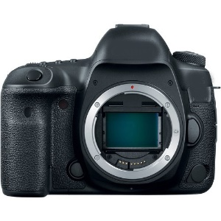 | Pcs | 3
2.Photocamera body type 2 | Camera Format: Full-Frame (1x Crop Factor)  Pixels Actual: 27.1 Megapixel Effective: 26.2 Megapixel  Maximum Resolution 6240 x 4160  Aspect Ratio 1:1, 3:2, 4:3, 16:9  Sensor Type: CMOS  ISO Sensitivity: Auto, 100 to 40000 (Extended: 50 to 102400); Mechanical Shutter 1/4000 to 30 Seconds  Shutter Speed: Bulb Mode  External Recording Modes: Full HD, HD  Resolution: 1,040,000 Dot  Display Type: Articulating Touchscreen LCD  Memory Card Slot: Single Slot: SD/SDHC/SDXC (UHS-I)  Wireless: Wi-Fi  Battery: 1 x LP-E6N Rechargeable Lithium-Ion, 7.2 VDC, 1865 mAh  Lens Mount: EF  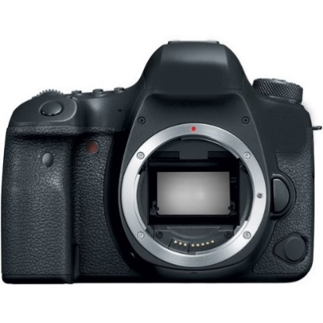 | Pcs | 4
3.Photocamera body type 3 | DIGIC 8 Image Processor  Lens Mount EF-S  Camera Format APS-C (1.6x Crop Factor)  Pixels Actual: 25.8 Megapixel Effective: 24.1 Megapixel  Maximum Resolution 6000 x 4000  Sensor Type CMOS  ISO Sensitivity Auto, 100 to 25600 (Extended: 100 to 51200)  Shutter Speed Mechanical Shutter 1/4000 to 30 Second  Recording Modes MP4/H.264 4:2:0 8-Bit, UHD 4K,Full HD, HD  Display Type Articulating Touchscreen LCD  Built-In Flash Yes  Memory Card Slot Single Slot: SD/SDHC/SDXC  Wireless Bluetooth Wi-Fi  Battery 1 x LP-E17 Rechargeable Lithium-Ion, 7.2 VDC, 1040 mAh (Approx. 1240 Shots)  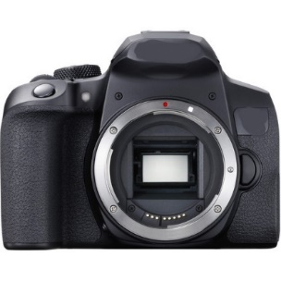 | Pcs | 1
4.Photocamera body type 4 | DIGIC 8 Image Processor  Lens Mount RF  Camera Format Full-Frame (1x Crop Factor)  Pixels Actual: 31.7 Megapixel Effective: 30.3 Megapixel  Maximum Resolution 6720 x 4480  Sensor Type CMOS  ISO Sensitivity Auto, 100 to 40000 (Extended: 50 to 102400)  Shutter Speed Electronic Front Curtain Shutter 1/8000 to 30 Seconds Bulb Mode  Recording Modes MP4/H.264, UHD 4K, Full HD,HD  Display Type Articulating Touchscreen LCD  Built-In Flash No  Memory Card Slot Single Slot: SD/SDHC/SDXC (UHS-II)  Wireless Wi-Fi Bluetooth  Battery 1 x LP-E6N Rechargeable Lithium-Ion, 7.2 VDC, 1865 mAh  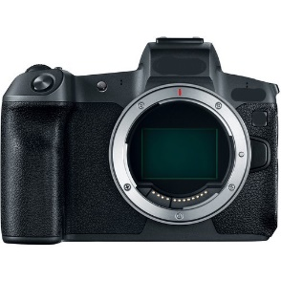 | Pcs | 2
5.Photocamera Body type 5 | DIGIC 6 Image Processor  Pixels Actual: 21.1 Megapixel Effective: 20.3 Megapixel  Maximum Resolution 5184 x 3888  Sensor Type CMOS  Image Stabilization Optical  Focal Length 4.3 to 215mm (35mm Equivalent Focal Length: 24 to 1200mm)  Optical Zoom 50x  Digital Zoom 4x Maximum (200x Combined Zoom)  ISO Sensitivity Auto, 80 to 3200  Shutter Speed 1/2000 to 15 Seconds  Recording Modes MP4/H.264/MPEG-4 Full HD, Full HD, HD, SD  Display Type Fixed LCD  Built-In Flash Yes  Memory Card Slot Single Slot: SD/SDHC/SDXC Battery 1 x NB-6LH Rechargeable Lithium-Ion, 3.7 VDC, 1070 mAh (Approx. 205 Shots)  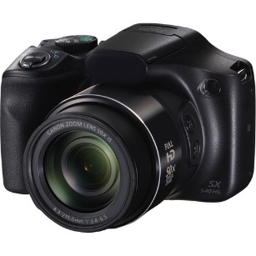 | Pcs | 3
6.Photocamera body type 6 | DIGIC 6 Image Processor  Lens Mount EF-S  Camera Format APS-C (1.6x Crop Factor)  Pixels Actual: 25.8 Megapixel Effective: 24.2 Megapixel  Maximum Resolution 6000 x 4000  Sensor Type CMOS  ISO Sensitivity Auto, 100 to 16000 (Extended: 100 to 25600)  Shutter Speed 1/8000 to 30 Seconds Bulb Mode  Recording Modes MOV Full HD,Full HD,MP4 Full HD [60 Mb/s], [30 Mb/s],[12 Mb/s]; HD [26 Mb/s], [4 Mb/s]  Display Type Articulating Touchscreen LCD  Memory Card Slot Single Slot: SD/SDHC/SDXC (UHS-I)  Battery 1 x LP-E6N Rechargeable Lithium-Ion, 7.2 VDC, 1865 mAh  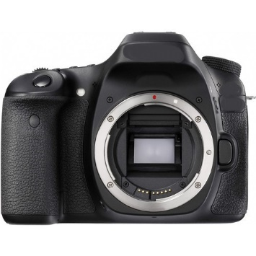 | Pcs | 2
7.Photocamera body type 7 | EXPEED 5 Image Processor  Lens Mount F  Camera Format Full-Frame (1x Crop Factor)  Pixels Actual: 46.89 Megapixel Effective: 45.7 Megapixel  Maximum Resolution 8256 x 5504  Sensor Type CMOS  ISO Sensitivity Auto, 64 to 25600 (Extended: 32 to 102400)  Shutter Speed 1/8000 to 30 Seconds Bulb Mode  Recording Modes MOV/MP4/H.264 UHD 4K, Full HD,HD  Display Type Tilting Touchscreen LCD  Memory Card Slot Slot 1: SD/SDHC/SDXC (UHS-II) Slot 2: XQD  Battery 1 x EN-EL15a Rechargeable Lithium-Ion  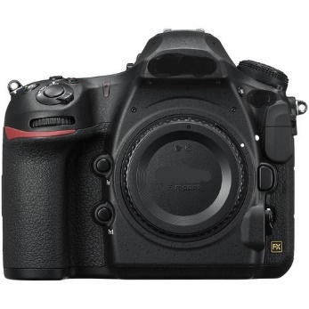 | Pcs | 1
8.Photocamera body type 8 | EXPEED 5 Image Processor  Lens Mount F  Camera Format APS-C (1.5x Crop Factor)  Pixels Actual: 21.51 Megapixel Effective: 20.9 Megapixel  Maximum Resolution 5568 x 3712  Sensor Type CMOS  ISO Sensitivity Auto, 100 to 51200 (Extended: 50 to 1640000)  Shutter Speed 1/8000 to 30 Seconds Bulb Mode  Recording Modes MOV/MP4/H.264 UHD 4K, Full HD, HD  Display Type Tilting Touchscreen LCD  Memory Card Slot Single Slot: SD/SDHC/SDXC (UHS-I)  Battery 1 x EN-EL15a Rechargeable Lithium-Ion  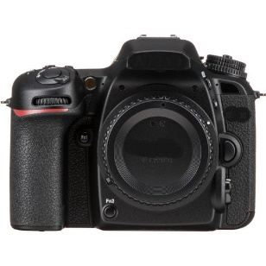 | Pcs | 2
9. Lens type 1 | Focal Length 24 to 105mm  Maximum Aperture f/3.5 to 5.6  Minimum Aperture f/22 to 32  Lens Mount EF  Format Compatibility Full-Frame  Minimum Focus Distance 1.31' / 40 cm  Maximum Magnification 0.3x  Optical Design 17 Elements in 13 Groups  Diaphragm Blades 7, Rounded  Focus Type Autofocus  Image Stabilization Yes  Filter Size 77 mm (Front)  Compatible with photocamera body type 2  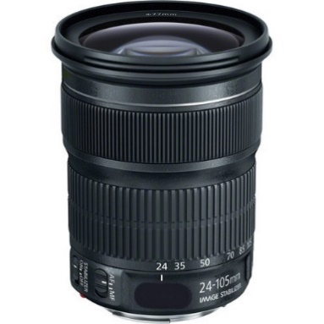 | Pcs | 1
10.Lens type 2 | Lens Mount EF  Focal Length 18 to 55mm  Minimum Aperture f/22 to 32  Minimum Focus Distance 9.84" / 25 cm  Optical Design 12 Elements in 10 Groups  Diaphragm Blades 7, Rounded  Focus Type Autofocus  Image Stabilization Yes  Filter Size 58 mm (Front)  Compatible with photocamera body type 3  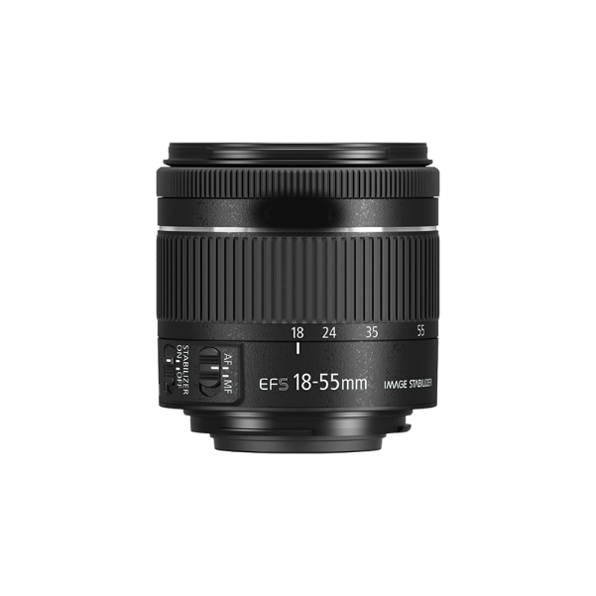 | Pcs | 1
11.Lens type 3 | Focal Length 70 to 200mm  Maximum Aperture f/2.8  Minimum Aperture f/32  Lens Mount EF  Format Compatibility Full-Frame  Minimum Focus Distance 4.92' / 1.5 m  Maximum Magnification 0.16x  Optical Design 18 Elements in 15 Groups  Diaphragm Blades 8, Rounded  Focus Type Autofocus  Image Stabilization None  Tripod Collar Removable and Rotating  Filter Size 77 mm (Front)  Compatible with photocamera body type 2  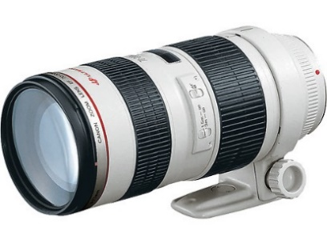 | Pcs | 1
12.Lens type 4 | Focal Length 50mm  Maximum Aperture f/1.8  Minimum Aperture f/22  Lens Mount EF  Format Compatibility Full-Frame  Minimum Focus Distance 13.78" / 35 cm  Maximum Magnification 0.21x  Optical Design 6 Elements in 5 Groups  Diaphragm Blades 7, Rounded  Focus Type Autofocus  Image Stabilization None  Filter Size 49 mm (Front)  Compatible with photocamera body type 2  Compatible with photocamera body type 4  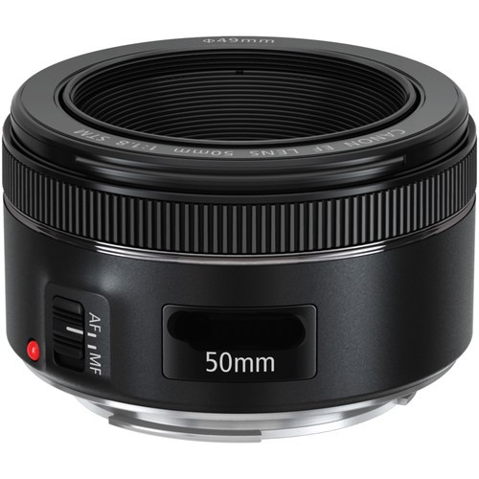 | Pcs | 2
13.Lens type 5 | Focal Length 24 to 70mm  Maximum Aperture f/2.8  Minimum Aperture f/22  Lens Mount EF  Format Compatibility Full-Frame  Minimum Focus Distance 38 cm  Maximum Magnification 0.29x  Optical Design 18 Elements in 13 Groups  Diaphragm Blades 8, Rounded  Focus Type Autofocus  Image Stabilization None  Filter Size 77 mm (Front)  Compatible with photocamera body type 1  Compatible with photocamera body type 2  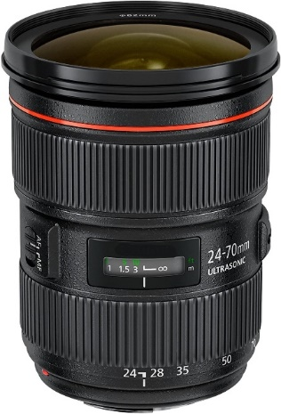 | Pcs | 2
14.Lens type 6 | Focal Length 24 to 70mm  Maximum Aperture f/2.8  Minimum Aperture f/22  Lens Mount EF  Format Compatibility Full-Frame  Minimum Focus Distance 1.25' / 38 cm  Maximum Magnification 0.21x  Optical Design 18 Elements in 13 Groups  Diaphragm Blades 9, Rounded  Focus Type Autofocus  Image Stabilization None  Filter Size 82 mm (Front)  Compatible with photocamera body type 2  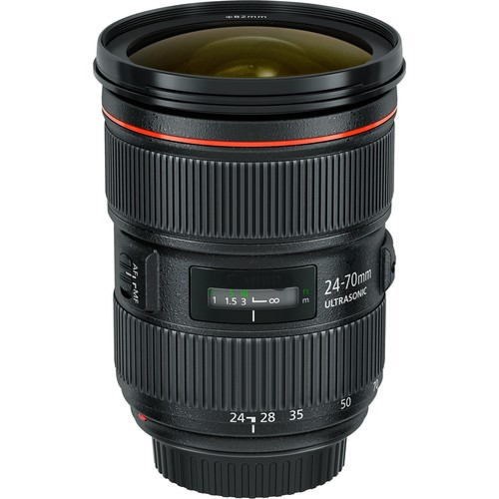 | Pcs | 1
15.Lens type 7 | Focal Length 50mm  Maximum Aperture f/1.2  Minimum Aperture f/16  Lens Mount EF  Format Compatibility Full-Frame  Minimum Focus Distance 1.48' / 45 cm  Maximum Magnification 0.15x  Optical Design 8 Elements in 6 Groups  Diaphragm Blades 8, Rounded  Focus Type Autofocus  Image Stabilization None  Filter Size 72 mm (Front)  Compatible with photocamera body type 1  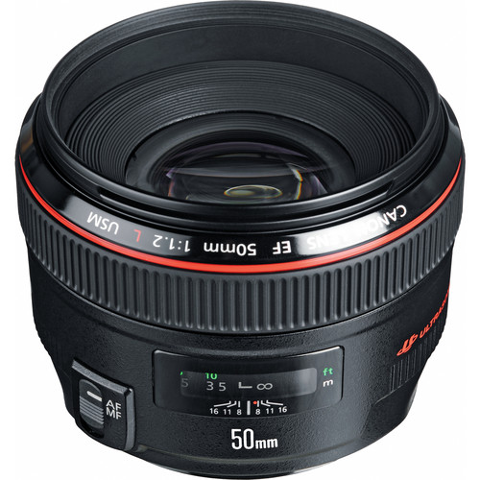 | Pcs | 1
16.Lens type 8 | Focal Length 24 to 105mm  Maximum Aperture f/4  Minimum Aperture f/22  Lens Mount RF  Format Compatibility Full-Frame  Minimum Focus Distance 1.48' / 45 cm  Maximum Magnification 0.24x  Optical Design 18 Elements in 14 Groups  Diaphragm Blades 9, Rounded  Focus Type Autofocus  Image Stabilization Yes  Filter Size 77 mm (Front)  Compatible with photocamera body type 4  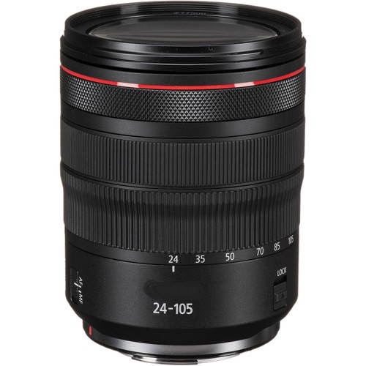 | Pcs | 1
17.Lens type 9 | EF-S-Mount Lens/APS-C Format  Focal Length 18 to 135mm (35mm Equivalent Focal Length: 28.8 to 216mm)  Maximum Aperture f/3.5 to 5.6  Minimum Aperture f/22 to 36  Lens Mount EF-S  Format Compatibility APS-C  Minimum Focus Distance 1.28' / 39 cm  Maximum Magnification 0.28x  Optical Design 16 Elements in 12 Groups  Diaphragm Blades 7, Rounded  Focus Type Autofocus  Image Stabilization Yes  Filter Size 67 mm (Front)  Compatible with photocamera body type 6  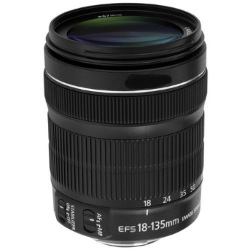 | Pcs | 2
18.Lens type 10 | Focal Length 18 to 140mm (35mm Equivalent Focal Length: 27 to 210mm)  Maximum Aperture f/3.5 to 5.6  Minimum Aperture f/22 to 38  Lens Mount F  Format Compatibility APS-C  Minimum Focus Distance 1.48' / 45 cm  Maximum Magnification 0.23x  Optical Design 17 Elements in 12 Groups  Diaphragm Blades 7, Rounded  Focus Type Autofocus  Image Stabilization Yes  Filter Size 67 mm (Front)  Compatible with photocamera body type 8  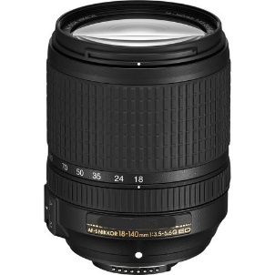 | Pcs | 2
19.Lens type 11 | Focal Length 70 to 200mm  Maximum Aperture f/2.8  Minimum Aperture f/22  Lens Mount F  Format Compatibility Full-Frame  Minimum Focus Distance 3.12' / 95 cm  Maximum Magnification 0.16x  Optical Design 23 Elements in 17 Groups  Diaphragm Blades 9, Rounded  Focus Type Autofocus  Image Stabilization Yes  Tripod Collar Removable and Rotating  Filter Size 77 mm (Front)  Compatible with photocamera body type 7  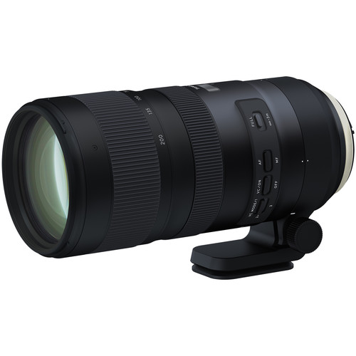 | Pcs | 1
20.Lens type 12 | Focal Length 35mm  Maximum Aperture f/1.4  Minimum Aperture f/16  Lens Mount EF  Format Compatibility Full-Frame  Minimum Focus Distance 11.81" / 30 cm  Maximum Magnification 0.19x  Optical Design 13 Elements in 11 Groups  Diaphragm Blades 9, Rounded  Focus Type Autofocus  Image Stabilization None  Filter Size 67 mm (Front)  Compatible with Photocamera body type 1  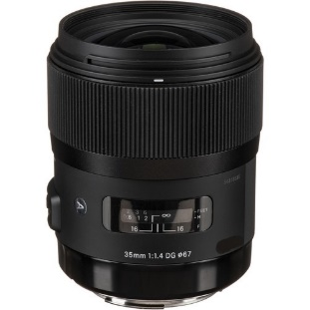 | Pcs | 1
21.Trigger | Frequency 2.4GHz  Range 150+m  Channels 4 channels  Groups 4 groups - A, B, C, D  Batteries 2 x AAA batteries (Transmitter and Receiver)  Max sync speed 1/250 sec  Attachment 1/4 tripod lug, cold shoe (Receiver)  Input voltage 2.5 to 3.2V  Minimum response time 350us  Top ports TTL port on the Top of transmitter  C/F port voltage handling 5V  Flash port voltage handling 6V (transmitter), 300V(receiver)  Compatible with photocamera body type 2  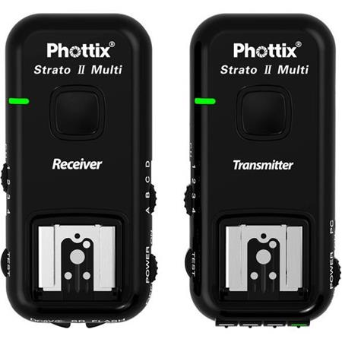 | Pcs | 2
22.Video light | Kit includes: (2)Bi-color LED Video Light with U Bracket  and Barndoor, (2)White Diffuser, (2)Power Adapter,  (2)Power Cable, (2)Carrying Case and (2)26 inches/66  centimeters-75 inches/190 centimeters Adjustable Light Stand  - LED Beads: 660 Pieces (330 White+330 Yellow)  - Power: 40W  - Color Temperature: 3200-5600K  - Lumen: 7300Lux/m  - Light Panel Size: 9.1x7.9x1.9 inches/23.2x20x4.8cm  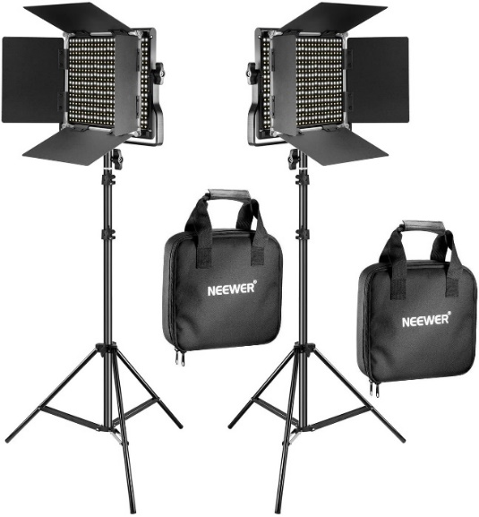 | Pcs | 2
23.Flashlight type 1 | Guide Number:  92' / 28.04 m at ISO 100 (35 mm Position)  Full-Frame 24 to 120 mm  Coverage:  12 mm (with Wide-Angle Adapter)  18 to 60° Vertical  25 to 78° Horizontal  Angle of Coverage:  100 to 120° Vertical (with Wide-Angle Adapter)  110 to 130° Horizontal (with Wide-Angle Adapter)  Auto Zoom Head: Yes  Bounce Head: -7 to +90°  Exposure Control: Manual, i-TTL  Flash Modes:  Hi-Speed Sync, Second-Curtain Sync, Slow Sync  Compatible with photocamera body type 7  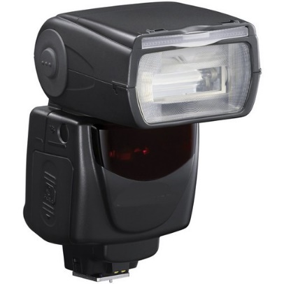 | Pcs | 1
24.Flashlight type 2 |  | Pcs | 1
  Guide Number: | 154.2' / 47 m at ISO 100 (105 mm Position)
  Coverage: | Full-Frame  24 to 105 mm  14 mm (with Wide AngleAdapter)
  Auto Zoom Head: | Yes
  Bounce Head: | 0 to +120°
  Swivel Head: | 360°
  Recycle Time: | Approx. 0.1 to 3.5 Seconds
  Exposure Control: | E-TTL / E-TTL II
  Flash Modes: | Second-Curtain Sync  Compatible with photocamera body type 2
   | 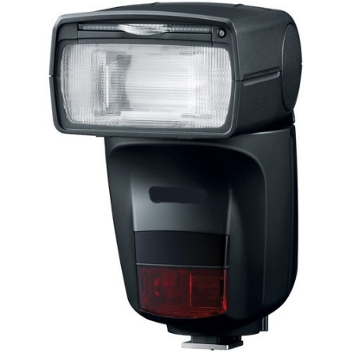
25.Flashlight type 3 | 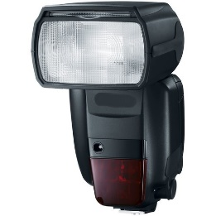 | Pcs | 2
  Guide Number | 197' / 60.05 m at ISO 100 (200 mm Position)
  Coverage | 20 to 200 mm  14 mm (with Wide-Angle Adapter)
  Angle of Coverage | 12 to 94°  114° (with Wide-Angle Adapter)
  Auto Zoom Head | Yes
  Bounce Head | -7 to +90°
  Swivel Head | 360°
  Flash Duration | 1/430 to 1/550 Second at Full Power
  Recycle Time | Approx. 0.1 to 5.5 Seconds
  Wireless Operation | Radio (TTL/Manual)  Up to 98.43' / 30 m  Optical Pulse (TTL/Manual)  Up to 49.21' / 15 m
  Wireless Channels | 4
  Wireless Groups | 5
  Compatible with photocamera body type 1
26.Crane type 1 | 14.3 lb Payload, Zoom and Focus Wheel  Redesigned Detachable SmartSling Handle  Updated Axis Locking System  ViaTouch 2.0 Remote Motion Control  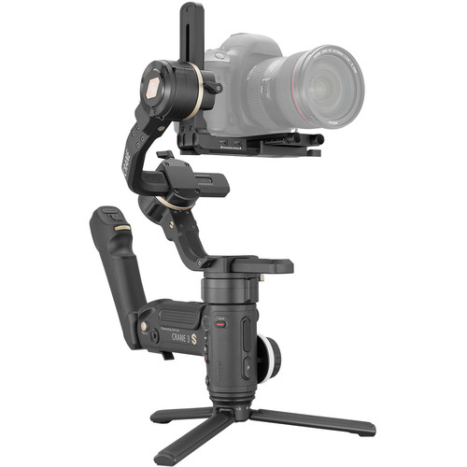 | Pcs | 2
  Number of Axes | 3-Axis (Pitch, Roll, Yaw)
  Rotation Range | Yaw(Pan): 360°  Pitch(Tilt): 360°  Roll: 330° (-255 to 75°)
  Load Capacity | 1.32 to 14.3 lb / 0.6 to 6.49 kg
  Battery Type | 3 x 18650
  Capacity (mAh) | 2600 mAh
  Battery Runtime | 12 Hours
  Mounting | 9 x 1/4"-20 Female
27.Crane type 2 | 9th Instune High Axis Response Algorithm  Large Camera Support: BMPCC 6K, S1H, 1DX  Dedicated TransMount Transmitter Mounts  Standard & Vertical Camera Mounts  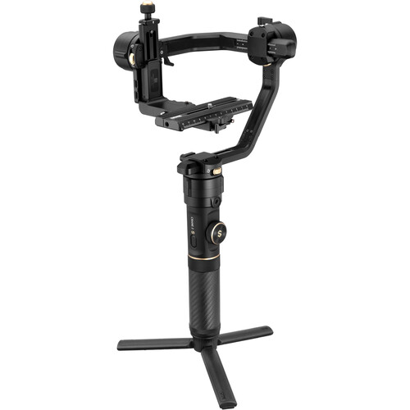 | Pcs | 1
  Number of Axes | 3-Axis (Pitch, Roll, Yaw)
  Rotation Range | Yaw (Pan):360°  Pitch(Tilt):-80 to 135°  Roll: -35 to 35°
  Battery Type | 3 x 18650
  Capacity (mAh) | 2600 mAh
  Battery Runtime | 12 Hours
  Battery Chemistry | Lithium-Ion
  Mounting | 3x1/4"-20Female  1 x 3/8"-16 Female
28.Action camera | Sensor 1-Chip CMOS  Sensor Resolution 12 MP  Focal Length 24.4 to 15.1mm  Recording Media 1 x microSD (256 GB Maximum)  Video Format 3840 x 2160p at 24/25/30/50/60 fps (78 Mb/s MP4 via H.264/AVC)  3840 x 2160p at 24/25/30/50/60 fps (78 Mb/s MP4 via H.265/HEVC)  2704 x 1520p at 24/25/30/50/60/100/120 fps (MP4)  1920 x 1440p at 24/25/30/50/60/100/120 fps (MP4)  1920 x 1080p at 24/25/30/50/60/100/120/200/240 fps (MP4)  1280 x 960p at 100/120/200/240 fps (MP4)  1280 x 720p at 50/60/200/240 fps (MP4)  Still Image Support JPEG  12 MP (4000 x 3000)  Shutter Speed 1/16000 - 1 Second (Video)  Photo ISO Range 100 to 6400 (Auto)  Video ISO Range 100 to 6400 (Auto)  Burst Photo 30 Photos / 1 Second  Image Stabilization Digital  Waterproof Depth Rating 33.0' / 10.0 m (Camera)  Built-In Mic Yes  Wi-Fi Yes  Battery Rechargeable Battery Pack, 3.85 VDC  Charging Method USB  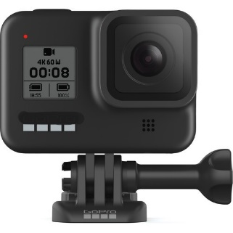 | Pcs | 1
29.Studio lighting kit | Studio Strobe × 3pcs  Light Stand 304(1.9cm) ×3pcs  Softbox SB-MS 6060cm ×1  Umbrella UB-002 33" ×1  Barndoor Kit BD-03 ×1  Remote Trigger RT-16 ×1  Carrying Bag CB-04 ×1  Sycn Line ×1  • Flash Output: 250WS or 300WS  • Guide Number (ISO100): 48m for 250WS strobe, 58 for 300WS strobe  • Color Temperature: 5600±200K  • Power Voltage: AC220V 50Hz / AC110-120V 60Hz  • Flash Power Control: 8 steps  • Modeling Lamp: 75W  • Recharging Time: 0.5-2s  • Flash Triggering Method: Sync cord, Slave, Test button  • Flash Duration: 1/2000-1/800s  • Fuse: 5A  • Flash Triggering Method: Sync cord,Test button,Slave  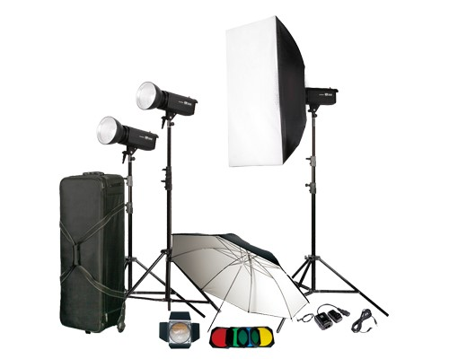 | Pcs | 1
30. satellite receiver | Hardware Features  CPU: GX6605S  Flash: 4mb  Power Source: External 12V/2A Adaptor  Front Panel Display: Digital LED 7 Segment Display  Video Output: AV, HDMI  USB Port: 2 Ports  Digital Optical Output: Yes Coaxial  RS232: Yes  LNB Loop: Yes  WiFi: USB WiFi MT7601 Included  Software Features  Operating System: Realtime OS  OSD Language: Russian, Persian, Arabic, Turkish, English  Resolution: 480I NTSC to 1080P  Supported Media: MKV, MP4, AVI, TS, MPEG  TimeShift Playback: Yes  Schedule Record: Yes  Record to Storage: USB, HDD upto 1TB  DiseqC Switche: DiseqC 1.0, 1.1, 1.2, USUALS  Channel Edit: Multiple Channel Move, Delete, FAV  Channel Scan Type: Manual / Auto / Blind / SuperBlind  Internet Applications: Youtube, Weather Forecast, Xtreamcodes, Stalker.  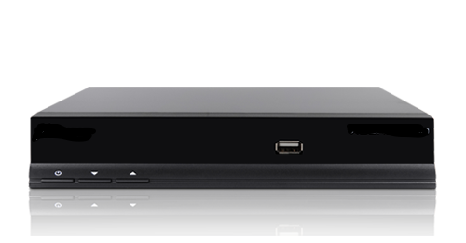 | Pcs | 1
31.Tripod | 33LBS Max Load, stable to take sharp picture. Max Stable Load up to 33 lbs (15 kg). The tripod offers high level of stability using great quality level of aluminum material. You can focus on composition and get ready for your photo or video without worrying your hand may be shaky. The quick release plate of ball head has a 1/4" Screw which is suitable for most cameras, camcorder, binocular and projectors.  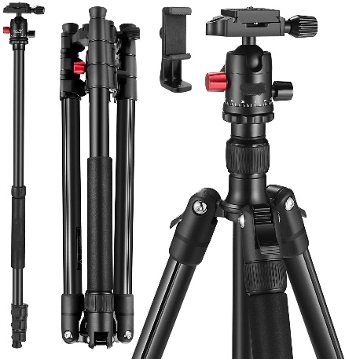 | Pcs | 7
  Material | Aluminum Alloy | Tripod Head Type | Ball Head | Counter Weight Hook | ✓
  Load Capacity | 33 lb | Diam. of Ball Joint | 28 mm | Phone holder | ✓
  Product Weight | 2.9 lb | Panning Range | 360° | Macro photography | ✓
  Max. Height | 157.5 sm | Tilt Range | 90° | Package Size | 18 * 4.7 * 4.7 in
  Min. Height | 53.34 sm | Bubble Spirit Level (No.) | 2 | Package Weight | 4.18 lb
  Storage Length | 44.45 sm | Head Locking Knob | ✓
  Max. Height converted to Monopod | 162,56sm | Separate Panning Knob | ✓
  Leg Lock Type | Flip Lock | Number of Leg Friction Control Sections | ✓
  Legs Tube Diameter | 25, 22, 19, 16 mm | Number of Leg Sections | 4
32.Monopod | Adjustable height in the range of 75-185sm  Quick Release Plate: Yes, with a 1/4" screw and one spare 3/8" screw  Tilt range: -75° to +90°  Pan range: 360°  Friction Control: Fixed  Bubble level: Yes  Diameter (bowl): 2.36"/60mm  Tilt Lock: Yes  Pan Lock: Yes  Pan Handle: Yes  The built-in ball joint enables the monopod to swivel 360° and be tilted 45° in any direction  Quick Release Plate: Yes, with a 1/4" screw and one spare 3/8" screw  Tilt range: -75° to +90°  Pan range: 360°  Friction Control: Fixed  Bubble level: Yes  Diameter (bowl): 2.36"/60mm  Tilt Lock: Yes  Pan Lock: Yes  Pan Handle: Yes  The built-in ball joint enables the monopod to swivel 360° and be tilted 45° in any direction  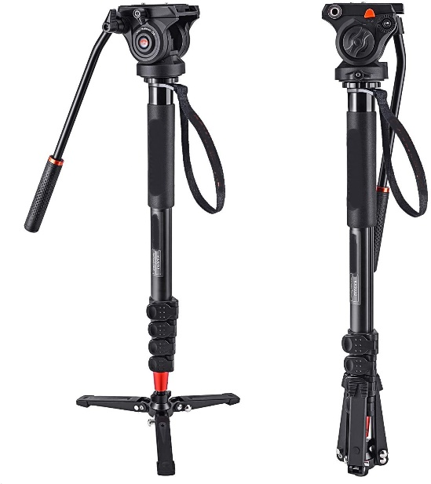 | Pcs | 2
33.Softbox type 1 | Compatible with Most Speedlights  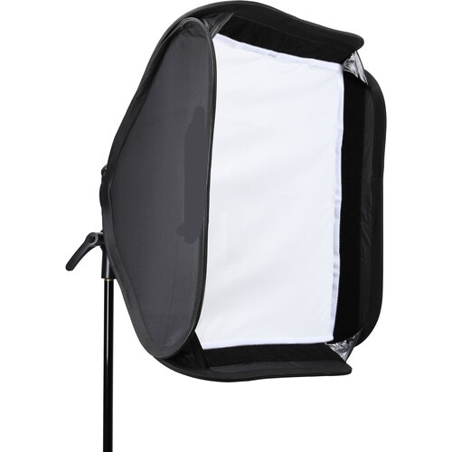 | Pcs | 1
  Shape | Square
  Interior | Silver
  Requires Speed Ring | No
  Accepts Grids | Yes
  Removable Front Face | Yes
  Removable Interior Baffle | Yes
  Material | Polyester
  Rectangular Dimensions | W: 59.9 x H: 59.9 cm (Open)
34.Softbox type 2 |  | Pcs | 1
  Shape | Square
  Interior | Silver
  Requires Speed Ring | No
  Accepts Grids | Yes
  Removable Front Face | Yes
  Removable Interior Baffle | Yes
  Material | Polyester
  Dimensions | W: 31.5 x H: 31.5" / W: 80.0 x H: 80.0 cm (Open)
  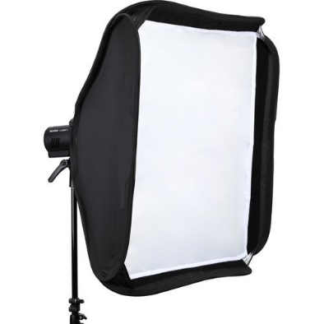
35.Softbox type 3 | For Shoe Mount Flash, 12-Sided Design  Shape Circular  Requires Speed Ring No  Circular Dimensions ø: 27.6" / ø: 70.0 cm (Open)  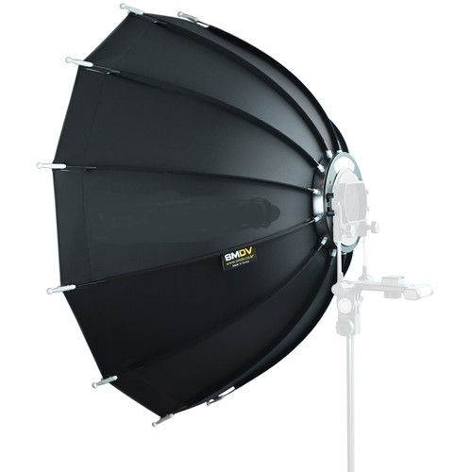 | Pcs | 3
36.Softbox type 4 | For Shoe-Mount Flashes  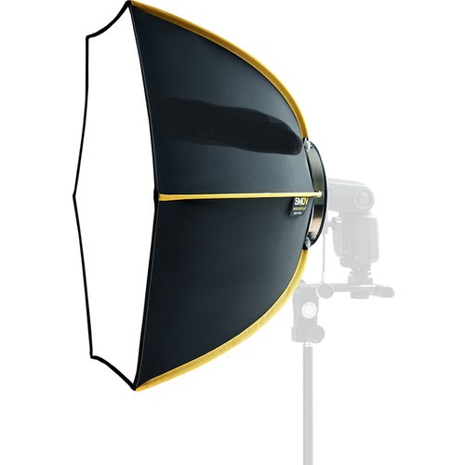 | Pcs | 1
  Shape | Hexagon
  Interior | Silver
  Requires Speed Ring | No
  Accepts Grids | Yes
  Removable Front Face | Yes
  Removable Interior Baffle | Yes
  Material | Nylon
  Circular Dimensions | ø: 24.0" / ø: 61.0 cm (Open)
37.Battery charger | Battery Type 4 x AA  Battery Chemistry NiMH  Battery Voltage 1.2 V  Capacity (mAh) 2550 mAh  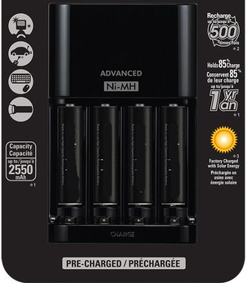 | Pcs | 1
38.Camera bag | Holds DSLR, 2 Lenses, & Flash  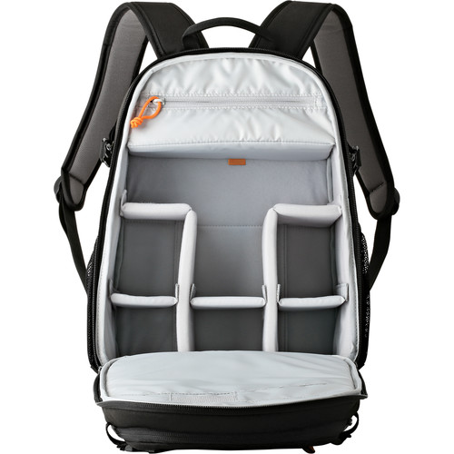 | Pcs | 2
  Exterior Dimensions | Capacity to hold one camera, battery, 5 lens,  flash light
  Exterior Material | Nylon, Polyester
  Type of Closure | Zipper
 |  | Pcs

Delivery Requirements
Delivery Requirements
Delivery date and time | Bidder shall deliver the goods in up to 45 days after Contract signature.
Delivery Terms (INCOTERMS 2020) | DAP Ganja, Sumgayit, Binagadi, Sabunchu, Goychay, Fizuli, Barda in line with the requirements in Annex 3.
Customs clearance  (must be linked to INCOTERM | ☐ Not applicable  Shall be done by:  ☐ Name of organisation (where applicable)  ☒ Supplier/bidder with the help of UNDP  ☐ Freight Forwarder
Exact Address(es) of Delivery Location(s) | Ganja, Sumgayit, Binagadi, Sabunchu, Goychay, Fizuli, Barda in line with the requirements in Annex 3. The exact addresses in these regions will be provided to the successful Bidder(s) after signing of the contract.
Distribution of shipping documents (if using freight forwarder) | The following documents to be submitted min 10 days before arrival:  Certificate of origin, Packing list, Commercial Invoice.  AWB to be sent as soon as issued, before arrival of the goods
Packing Requirements | Packing shall be of an efficient and effective standard to protect the Goods against the hazards associated with handling during loading and unloading while in transits, delivery and storage at the destination places. The packages shall allow for distribution to several addresses within each region.
Training on Operations and Maintenance | Instructing on how to operate and maintain equipment is required.
Warranty Period | 12 months
After-sales service and local service support requirements | Required. The after-sale service shall be available in Azerbaijan.
Preferred Mode of Transport | Air  No specific delivery mode is required. The Bidder may deliver by air or by land or using a multimodal transport mode.

ANNEX 2: QUOTATION SUBMISSION FORM
Bidders are requested to complete this form, including the Company Profile and Bidder’s Declaration, sign it and return it as part of their quotation along with Annex 3: Technical and Financial Offer. The Bidder shall fill in this form in accordance with the instructions indicated. No alterations to its format shall be permitted and no substitutions shall be accepted.
Name of Bidder: | Click or tap here to enter text.
RFQ reference: | Click or tap here to enter text. | Date: Click or tap to enter a date.

Company Profile
Item Description |  | Detail
Legal name of bidder or Lead entity for JVs |  | Click or tap here to enter text.
Legal Address, City, Country |  | Click or tap here to enter text.
Website |  | Click or tap here to enter text.
Year of Registration |  | Click or tap here to enter text.
Legal structure |  | Choose an item.
Are you a UNGM registered vendor? |  | ☐ Yes ☐ No If yes, insert UNGM Vendor Number
Quality Assurance Certification (e.g. ISO 9000 or Equivalent) (If yes, provide a Copy of the valid Certificate): |  | ☒ Yes ☐ No
Does your Company hold any accreditation such as ISO 14001 or ISO 14064 or equivalent related to the environment? (If yes, provide a Copy of the valid Certificate): |  | ☒ Yes ☐ No
Does your Company have a written Statement of its Environmental Policy? (If yes, provide a Copy) |  | ☒ Yes ☐ No
Does your organization demonstrate significant commitment to sustainability through some other means, for example internal company policy documents on women empowerment, renewable energies or membership of trade institutions promoting such issues (If yes, provide a Copy) |  | ☒ Yes ☐ No
Is your company a member of the UN Global Compact |  | ☒ Yes ☐ No
Bank Information |  | Bank Name: Click or tap here to enter text.  Bank Address: Click or tap here to enter text.  IBAN: Click or tap here to enter text.  SWIFT/BIC: Click or tap here to enter text.  Account Currency: Click or tap here to enter text.  Bank Account Number: Click or tap here to enter text.
Previous relevant experience: 2 contracts
Name of previous contracts | Client & Reference Contact Details including e-mail |  | Contract Value | Period of activity | Types of activities undertaken

Bidder’s Declaration
Yes | No
☐ | ☐ | Requirements and Terms and Conditions: I/We have read and fully understand the RFQ, including the RFQ Information and Data, Schedule of Requirements, the General Conditions of Contract, and any Special Conditions of Contract. I/we confirm that the Bidder agrees to be bound by them.
☐ | ☐ | I/We confirm that the Bidder has the necessary capacity, capability, and necessary licenses to fully meet or exceed the Requirements and will be available to deliver throughout the relevant Contract period.
☐ | ☐ | Ethics: In submitting this Quote I/we warrant that the bidder: has not entered into any improper, illegal, collusive or anti-competitive arrangements with any Competitor; has not directly or indirectly approached any representative of the Buyer (other than the Point of Contact) to lobby or solicit information in relation to the RFQ ;has not attempted to influence, or provide any form of personal inducement, reward or benefit to any representative of the Buyer.
☐ | ☐ | I/We confirm to undertake not to engage in proscribed practices, , or any other unethical practice, with the UN or any other party, and to conduct business in a manner that averts any financial, operational, reputational or other undue risk to the UN and we have read the United Nations Supplier Code of Conduct :https://www.un.org/Depts/ptd/about-us/un-supplier-code-conduct and acknowledge that it provides the minimum standards expected of suppliers to the UN.
☐ | ☐ | Conflict of interest: I/We warrant that the bidder has no actual, potential, or perceived Conflict of Interest in submitting this Quote or entering a Contract to deliver the Requirements. Where a Conflict of Interest arises during the RFQ process the bidder will report it immediately to the Procuring Organisation’s Point of Contact.
☐ | ☐ | Prohibitions, Sanctions: l/We hereby declare that our firm, its affiliates or subsidiaries or employees, including any JV/Consortium members or subcontractors or suppliers for any part of the contract is not under procurement prohibition by the United Nations, including but not limited to prohibitions derived from the Compendium of United Nations Security Council Sanctions Lists and have not been suspended, debarred, sanctioned or otherwise identified as ineligible by any UN Organization or the World Bank Group or any other international Organization.
☐ | ☐ | Bankruptcy: l/We have not declared bankruptcy, are not involved in bankruptcy or receivership proceedings, and there is no judgment or pending legal action against them that could impair their operations in the foreseeable future.
☐ | ☐ | Offer Validity Period: I/We confirm that this Quote, including the price, remains open for acceptance for the Offer Validity.
☐ | ☐ | I/We understand and recognize that you are not bound to accept any Quotation you receive, and we certify that the goods offered in our Quotation are new and unused.
☐ | ☐ | By signing this declaration, the signatory below represents, warrants and agrees that he/she has been authorised by the Organization/s to make this declaration on its/their behalf.

Signature:
Name: Click or tap here to enter text.
Title: Click or tap here to enter text.
Date: Click or tap to enter a date.

ANNEX 3: TECHNICAL AND FINANCIAL OFFER - GOODS
Bidders are requested to complete this form, sign it and return it as part of their bid along with Annex 2: Quotation Submission Form. The Bidder shall fill in this form in accordance with the instructions indicated. No alterations to its format shall be permitted and no substitutions shall be accepted.
Name of Bidder: | Click or tap here to enter text.
RFQ reference: | Click or tap here to enter text. | Date: Click or tap to enter a date.

Currency of the Quotation: Click or tap here to enter text.
INCOTERMS: Click or tap here to enter text.
Item No | Description | UOM | Qty | Unit price | Total price
1. | Photocamera body type 1 | Pcs | Total:3  Ganja-1  Sumqayit-2
2. | Photocamera body type 2 | pcs | Total:4  Sumqayit-1  Sabunchu-1  Binagadi-2
3. | Photocamera body type 3 | pcs | Total:1  Ganja-1
4. | Photocamera body type 4 | pcs | Total:2  Sumqayit-2
5. | Photocamera Body type 5 | pcs | Total:3 Ganja-3
6. | Photocamera body type 6 | pcs | Total:2  Goychay-1  Sabunchu-1
7. | Photocamera body type 7 | pcs | Total:1  Binagadi-1
8. | Photocamera body type 8 | Pcs | Total:2  Fuzuli-1  Barda-1
9 | Lens type 1 | pcs | Total: 1  Sumqayit-1
10 | Lens type 2 | pcs | Total:1  Ganja-1
11 | Lens type 3 | pcs | Total:1  Binagadi -1
12 | Lens type 4 | pcs | Total:2  Binagadi-1  Sumqayit-1
13 | Lens type 5 | pcs | Total:2  Binagadi-1  Sumqayit-1
14 | Lens type 6 | Pcs | Total:1  Sabunchu-1
15 | Lens type 7 | Pcs | Total:1  Sumqayit-1
16 | Lens type 8 | Pcs | Total:1  Sumqayit -1
17 | Lens type 9 | Pcs | Total:2  Sabunchu-1  Goychay-1
18 | Lens type 10 | pcs | Total:2  Fuzuli-1  Barda-1
19 | Lens type 11 | pcs | Total:1  Binagadi-1
20 | Lens type 12 | pcs | Total:1  Ganja-1
21 | Trigger | pcs | Total:2  Binagadi-2
22 | Video light | pcs | Total:2  Binagadi-1  Sumqayit-1
23 | Flashlight type 1 | pcs | Total:1  Binagadi-1
24 | Flashlight type 2 | pcs | Total:1  Sabunchu-1
25 | Flashlight type 3 | pcs | Total:2  Sumqayit-2
26 | Crane type 1 | pcs | Total:2  Binagadi-1  Goychay-1
27 | Crane type 2 | pcs | Total:1  Binagadi-1
28 | Action camera | pcs | Total:1  Goychay-1
29 | Studio lighting kit | pcs | Total:1  Sumqayit-1
30 | Satellite receiver | pcs | Total:1  Barda-1
31 | Tripod | pcs | Total:7  Sumqayit-2  Binagadi-1  Goychay-1  Sabunchu-2  Barda-1
32 | Monopod | pcs | Total:2  Binagadi-2
33 | Softbox type 1 | pcs | Total:1  Sumqayit-1
34 | Softbox type 2 | pcs | Total:1  Sumqayit-1
35 | Softbox type 3 | pcs | Total:3  Sumqayit-1  Binagadi-1  Sabunchu-1
36 | Softbox type 4 | pcs | Total:1  Binagadi-1
37 | Battery charger | pcs | Total:1  Sabunchu-1
38 | Camera bag | Pcs | Total:2  Sabunchu-1  Binagadi-1
Total Price
Transportation Price
Insurance Price
Installation Price
Training Price
Other Charges (specify)
Total Final and All-inclusive Price

Compliance with Requirements
 | You Responses
 | Yes, we will comply | No, we cannot comply | If you cannot comply, pls. indicate counter - offer
Minimum Technical Specifications | ☐ | ☐ | Click or tap here to enter text.
Delivery Term (INCOTERMS) | ☐ | ☐ | Click or tap here to enter text.
Delivery Lead Time | ☐ | ☐ | Click or tap here to enter text.
Warranty and After-Sales Requirements | ☐ | ☐ | Click or tap here to enter text.
Validity of Quotation | ☐ | ☐ | Click or tap here to enter text.
Payment terms | ☐ | ☐ | Click or tap here to enter text.
Other requirements [pls. specify] | ☐ | ☐ | Click or tap here to enter text.

Other Information:
Estimated weight/volume/dimension of the Consignment: | Click or tap here to enter text.
Country/ies of Origin:  (if export licence required this must be submitted if awarded the contract) | Click or tap here to enter text.

I, the undersigned, certify that I am duly authorized to sign this quotation and bind the company below in event that the quotation is accepted.
Exact name and address of company  Company NameClick or tap here to enter text.  Address: Click or tap here to enter text.  Click or tap here to enter text.  Phone No.: Click or tap here to enter text.  Email Address: Click or tap here to enter text. | Authorized Signature:  Date: Click or tap here to enter text.  Name: Click or tap here to enter text.  Functional Title of Authorised  Signatory: Click or tap here to enter text.  Email Address: Click or tap here to enter text.

