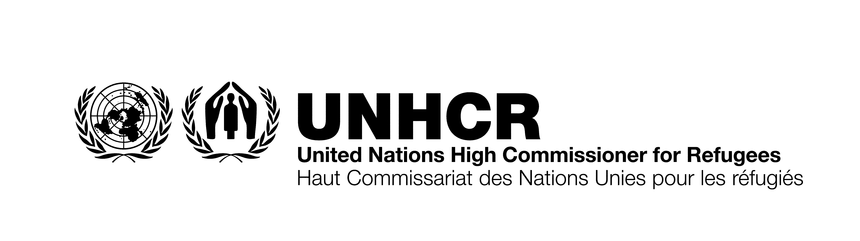

ITB No.: ITB/AZE/004/2021
SUPPLY OF SERVERS & NETWORK SECURITY SYSTEMS FOR UNHCR BAKU, AZERBAIJAN

Annex C
Financial Offer Form
[To be completed by the bidder]

No | Item descriptions | Qty. | Unit Price | Total Price
1 | Lot 1  Servers  Specification: | 3
2 | Lot 2  Network Security System  Specification:  Network Security Device | 2
 | Subscriptions | 2
 | Support | 2
 | Installation and migration services | 2
Total Price inclusive of Delivery |  | Manats

Note:
- UNHCR will consider offers for partial list of items in the ITB from responding vendors and may decide on partial award. Therefore, suppliers may wish to provide offer for either of the items in ITB.

Company Name: ------------------------------------- Authorized person: --------------------------------------

E-mail: ------------------------------------------------ Mobile phone: ---------------------------------------------

Delivery Completion Date: Offer Validity for 60 days: Yes □ No □

Date: ----------------------- Ref: ---------------- Signature: Stamp:

