REQUEST FOR QUOTATION (RFQ)

RFQ Reference: RFQ for TV Studio Equipment | RFQ for Purchasing Equipment for TV Studio.  Date: 13 June 2022

SECTION 1: REQUEST FOR QUOTATION (RFQ)

UNDP kindly requests your quotation for the provision of goods, works and/or services as detailed in Annex 1 of this RFQ.
This Request for Quotation comprises the following documents: Section 1: This request letter
Section 2: RFQ Instructions and Data Annex 1: Schedule of Requirements Annex 2: Quotation Submission Form Annex 3: Technical and Financial Offer

When preparing your quotation, please be guided by the RFQ Instructions and Data. Please note that quotations must be submitted using Annex 2: Quotation Submission Form and Annex 3 Technical and Financial Offer, by the method and by the date and time indicated in Section 2. It is your responsibility to ensure that your quotation is submitted on or before the deadline. Quotations received after the submission deadline, for whatever reason, will not be considered for evaluation.
Thank you and we look forward to receiving your quotations.

Signature: Name: Subhan Ahmadov
Title: Operations Manager UNDP, Azerbaijan Date: 13.06.2022

SECTION 2: RFQ INSTRUCTIONS AND DATA

Introduction | Bidders shall adhere to all the requirements of this RFQ, including any amendments made in writing by UNDP. This RFQ is conducted in accordance with the UNDP Programme and Operations Policies and Procedures (POPP) on Contracts and Procurement  Any Bid submitted will be regarded as an offer by the Bidder and does not constitute or imply the acceptance of the Bid by UNDP. UNDP is under no obligation to award a contract to any Bidder as a result of this RFQ.  UNDP reserves the right to cancel the procurement process at any stage without any liability of any kind for UNDP, upon notice to the bidders or publication of cancellation notice on UNDP website.
Deadline for the Submission of Quotation | 27th June 2022 18:00 Baku time  If any doubt exists as to the time zone in which the quotation should be submitted, refer to http://www.timeanddate.com/worldclock/.  For eTendering submission - as indicated in eTendering system. Note that system time zone is in EST/EDT (New York) time zone.
Method of Submission | Quotations must be submitted as follows:  - E-tendering  ☒Dedicated Email Address  - Courier / Hand delivery  - Other Click or tap here to enter text.  [For eTendering method, click the link https://etendering.partneragencies.org and insert Event ID information]  - Insert BU Code  - and Event ID number  Detailed instructions on how to submit, modify or cancel a bid in the eTendering system are provided in the eTendering system Bidder User Guide and Instructional videos available on this link: http://www.undp.org/content/undp/en/home/operations/procurement/business/procurement- notices/resources/
Cost of preparation  of quotation | UNDP shall not be responsible for any costs associated with a Supplier’s preparation and submission of a quotation, regardless of the outcome or the manner of conducting the selection process.
Supplier Code of Conduct, | All prospective suppliers must read the United Nations Supplier Code of Conduct and acknowledge that it provides the minimum standards expected of suppliers to the UN. The Code of Conduct, which includes principles on labour, human rights, environment and ethical conduct may be found  at: https://www.un.org/Depts/ptd/about-us/un-supplier-code-conduct

Fraud, Corruption, | Moreover, UNDP strictly enforces a policy of zero tolerance on proscribed practices, including fraud, corruption, collusion, unethical or unprofessional practices, and obstruction of UNDP vendors and requires all bidders/vendors to observe the highest standard of ethics during the procurement  process and contract implementation. UNDP’s Anti-Fraud Policy can be found at http://www.undp.org/content/undp/en/home/operations/accountability/audit/office_of_audit_an dinvestigation.html#anti
Gifts and Hospitality | Bidders/vendors shall not offer gifts or hospitality of any kind to UNDP staff members including recreational trips to sporting or cultural events, theme parks or offers of holidays, transportation, or invitations to extravagant lunches, dinners or similar. In pursuance of this policy, UNDP: (a) Shall reject a bid if it determines that the selected bidder has engaged in any corrupt or fraudulent practices in competing for the contract in question; (b) Shall declare a vendor ineligible, either indefinitely or for a stated period, to be awarded a contract if at any time it determines that the vendor has engaged in any corrupt or fraudulent practices in competing for, or in executing a UNDP contract.
Conflict of Interest | UNDP requires every prospective Supplier to avoid and prevent conflicts of interest, by disclosing to UNDP if you, or any of your affiliates or personnel, were involved in the preparation of the requirements, design, specifications, cost estimates, and other information used in this RFQ. Bidders shall strictly avoid conflicts with other assignments or their own interests, and act without consideration for future work. Bidders found to have a conflict of interest shall be disqualified.  Bidders must disclose in their Bid their knowledge of the following: a) If the owners, part-owners, officers, directors, controlling shareholders, of the bidding entity or key personnel who are family members of UNDP staff involved in the procurement functions and/or the Government of the country or any Implementing Partner receiving goods and/or services under this RFQ.  The eligibility of Bidders that are wholly or partly owned by the Government shall be subject to UNDP’s further evaluation and review of various factors such as being registered, operated and managed as an independent business entity, the extent of Government ownership/share, receipt of subsidies, mandate and access to information in relation to this RFQ, among others. Conditions that  may lead to undue advantage against other Bidders may result in the eventual rejection of the Bid.
General Conditions of Contract | Any Purchase Order or contract that will be issued as a result of this RFQ shall be subject to the General Conditions of Contract  Select the applicable GTC:  X General Terms and Conditions / Special Conditions for Contract.  - General Terms and Conditions for de minimis contracts (services only, less than $50,000)  - General Terms and Conditions for Works  Applicable Terms and Conditions and other provisions are available at UNDP/How-we-buy
Special Conditions of  Contract | X Cancellation of PO/Contract if the delivery/completion is delayed by [30 days]  - Others [pls. specify]
Eligibility | A vendor who will be engaged by UNDP may not be suspended, debarred, or otherwise identified as ineligible by any UN Organization or the World Bank Group or any other international Organization. Vendors are therefore required to disclose to UNDP whether they are subject to any sanction or temporary suspension imposed by these organizations. Failure to do so may result in termination of any contract or PO subsequently issued to the vendor by UNDP.  It is the Bidder’s responsibility to ensure that its employees, joint venture members, sub-contractors, service providers, suppliers and/or their employees meet the eligibility requirements as established by UNDP.  Bidders must have the legal capacity to enter a binding contract with UNDP and to deliver in the country, or through an authorized representative
Currency of  Quotation | Quotations shall be quoted in USD (United States Dollars)

Joint Venture, Consortium or Association | If the Bidder is a group of legal entities that will form or have formed a Joint Venture (JV), Consortium or Association for the Bid, they shall confirm in their Bid that : (i) they have designated one party to act as a lead entity, duly vested with authority to legally bind the members of the JV, Consortium or Association jointly and severally, which shall be evidenced by a duly notarized Agreement among the legal entities, and submitted with the Bid; and (ii) if they are awarded the contract, the contract shall be entered into, by and between UNDP and the designated lead entity, who shall be acting for and on behalf of all the member entities comprising the joint venture, Consortium or Association.  Refer to Clauses 19 – 24 under Solicitation policy for details on the applicable provisions on Joint  Ventures, Consortium or Association.
Only one Bid | The Bidder (including the Lead Entity on behalf of the individual members of any Joint Venture, Consortium or Association) shall submit only one Bid, either in its own name or, if a joint venture, Consortium or Association, as the lead entity of such Joint Venture, Consortium or Association.  Bids submitted by two (2) or more Bidders shall all be rejected if they are found to have any of the following:  - they have at least one controlling partner, director or shareholder in common; or b) any one of them receive or have received any direct or indirect subsidy from the other/s; or  - they have the same legal representative for purposes of this RFQ; or  - they have a relationship with each other, directly or through common third parties, that puts them in a position to have access to information about, or influence on the Bid of, another Bidder regarding this RFQ process;  - they are subcontractors to each other’s Bid, or a subcontractor to one Bid also submits another Bid under its name as lead Bidder; or  - some key personnel proposed to be in the team of one Bidder participates in more than one Bid received for this RFQ process. This condition relating to the personnel, does not apply to  subcontractors being included in more than one Bid.
Duties and taxes | Article II, Section 7, of the Convention on the Privileges and Immunities provides, inter alia, that the United Nations, including UNDP as a subsidiary organ of the General Assembly of the United Nations, is exempt from all direct taxes, except charges for public utility services, and is exempt from customs restrictions, duties, and charges of a similar nature in respect of articles imported or exported for its official use. All quotations shall be submitted net of any direct taxes and any other taxes and duties, unless otherwise specified below:  All prices must:  - be inclusive of VAT and other applicable indirect taxes  ☒ be exclusive of VAT and other applicable indirect taxes
Language of quotation | English  Including documentation including catalogues, instructions, and operating manuals.
Documents to be submitted | Bidders shall include the following documents in their quotation:  ☒ Annex 2: Quotation Submission Form duly completed and signed  ☒ Annex 3: Technical and Financial Offer duly completed and signed and in accordance with the Schedule of Requirements in Annex 1  ☒ Company Profile  ☒ Registration certificate  ☒ List and value of projects in IT sector performed for the last 3 years plus client’s contact details who may be contacted for further information on those contracts.  ☒ Standard manufacturer warranty  ☒ Quality Certificates (ISO, etc.), for products  ☒ Other Written Self-Declaration of not being included in the UN Security Council 1267/1989 list, UN Procurement Division List or other UN Ineligibility List.  ☒ Works/Services carried out by the vendor in the past, with address and contacts of previous clients to be available for due diligence. Works and Services must be in the related field (similar services and equipment indicated in the RFQ), including trainings provided  ☒ Minimum 3 years of experience in specifically in the field indicated in the RFQ  ☒ Two reference letters signed and stamped by the referee vendor indicating the nature and volume of the works, it should be similar services  ☒ The bidder should have at least 300.000 USD turnover for the last three years overall, proven with the official statement form/letter from the local TAX authorities

Quotation validity  period | Quotations shall remain valid for 90 days from the deadline for the Submission of Quotation.
Price variation | No price variation due to escalation, inflation, fluctuation in exchange rates, or any other market factors shall be accepted at any time during the validity of the quotation after the quotation has been  received.
Partial Quotes | ☒ Not permitted
Alternative Quotes | ☒ Not permitted
Payment Terms | ☒ 70% payment upon delivery of all equipment and installation (testing included)  ☒ 30% upon delivery of all services (including training, testing with the team of VET centers)  - Other Click or tap here to enter text.  Note: all payments will be released once the management of the VET center confirmed the delivery of all products and services indicated in the RFQ
Conditions for Release of Payment | - Passing Inspection [specify method, if possible] Complete Installation  - Passing all Testing [specify standard, if possible]  - Completion of Training on Operation and Maintenance [specify no. of trainees, and location of training, if possible  ☒ Written Acceptance of Goods, Services and Works, based on full compliance with RFQ requirements  - Others [pls. specify]
Contact Person for correspondences, notifications and  clarifications | E-mail address: procurement.aze@undp.org  Any delay in UNDP’s response shall be not used as a reason for extending the deadline for submission, unless UNDP determines that such an extension is necessary and communicates a new deadline to the Proposers.
Clarifications and  questions | Requests for clarification from bidders will not be accepted any later than 5 days before the submission deadline.
Evaluation method | ☒The Contract or Purchase Order will be awarded to the lowest price substantially compliant offer  - Other Click or tap here to enter text.
Questions and clarifications | Interested bidders shall send email only to the email address indicated below for clarifications and questions not later than 15th of June 2022, 18:00 pm by local time Baku, Azerbaijan.  Procurement.aze@undp.org
Evaluation criteria | ☒Full compliance with all requirements as specified in Annex 1  ☒Full acceptance of the General Conditions of Contract  - Comprehensiveness of after-sales services  - Earliest Delivery /shortest lead time  - Others Click or tap here to enter text.

Right not to accept any  quotation | UNDP is not bound to accept any quotation, nor award a contract or Purchase Order
Right to vary requirement at time of  award | At the time of award of Contract or Purchase Order, UNDP reserves the right to vary (increase or decrease) the quantity of services and/or goods, by up to a maximum twenty-five per cent (25%) of the total offer, without any change in the unit price or other terms and conditions.
Type of Contract to be awarded | ☒ Purchase Order  - Contract Face Sheet (Goods and-or Services) (this template is also utilized for Long-Term Agreement) and if an LTA will be signed, specify the document that will trigger the call-off. E.g., PO, etc.)  ☒ Contract for Works  - Other Type/s of Contract [pls. specify]
Expected date for contract  award | July 2022
Publication of Contract  Award | UNDP will publish the contract awards valued at USD 100,000 and more on the websites of the CO and the corporate UNDP Web site.
Policies and procedures | This RFQ is conducted in accordance with UNDP Programme and Operations Policies and Procedures
UNGM  registration | Any Contract resulting from this RFQ exercise will be subject to the supplier being registered at the appropriate level on the United Nations Global Marketplace (UNGM) website at www.ungm.org. The Bidder may still submit a quotation even if not registered with the UNGM, however, if the Bidder is selected for Contract award, the Bidder must register on the UNGM prior to contract  signature.

ANNEX 1: SCHEDULE OF REQUIREMENTS
Background:
The project “VET for the future: development of VET providers’ excellence in Azerbaijan” is intended to support the modernization of VET institutions in Azerbaijan to deliver competence-based training in order to increase the attractiveness and labour market relevance of VET. Project activities will be piloted in seven VET schools/centers (four in Baku and three in the regions - Ganja, Jalilabad and Sheki). The selected schools are priority for the Ministry of Education and have been selected based on factors such as labor market relevance, scaling up VET priority sectors for country development, private sector interest and the existence of required infrastructure. The project’s initiatives/activities will promote public-private cooperation and partnership in the field of work-based learning; build robust capacity of the VET institutions to offer new educational content; and boost the attractiveness of VET education for young people.
Equipment for the workshops/learning factories are planned to be established in the seven targeted VET schools to implement the innovations described in the other activities of the project under Pillar 1. The workshops will enable the teaching of the following programs envisaged under Pillar 1: long-term and short-time courses, work-based internship programmes, dual programmes, digitalization and future skills programmes and training courses for PwDs.
Scope of Services:
The project intending to support establishment of TV studio with purchasing of all needed technical equipment to support teaching of VET students and young people within the short- and long-term education programme, covering many directions from cameraman, voice over and others.

Buzovna VET Center N5
№ | List of equipment | Unit | Quantity
1 | 4K XDCAM Camcorder  Features: A single Exmor RS sensor with a UHD 4K (3840 x 2160) resolution, G lens with 12x optical zoom range, and 18/24x Clear Image Zoom in 4K/HD. Recording 4K in XAVC Long at 4:2:0 8-bit, and HD in XAVC Long at 4:2:2 10-bit, as well as MPEG2HD at 4:2:2 or 4:2:0 in 8-bit only.  Recording to a variety of formats: 100 Mb/s XAVC Long GOP recording of 4K UHD video at up to 29.97p, HD up to 59.94p, MPEG HD up to 59.94p, and AVCHD 2.0 up to 59.94p.  Footage is recorded to media via two SD memory card slots. It features built-in Wi-Fi and NFC connectivity, two 3-pin XLR audio inputs that support line, mic, and mic + 48V (phantom power) for using external microphones and Night Shot capability.  Item package includes: 4K XDCAM Camcorder; Lens Hood; Large Eyecup; Shoe Cap; Accessory Shoe Kit (1x Accessory Shoe, 1x Accessory Shoe Plate, 4x Screws); USB Cable; AC-L100 AC Adapter; AC Cable; NP-F770 L-Series Info-Lithium Battery Pack (7.2v, 4400mAh); Battery Charger; Infrared Remote Commander (RMT-845); CR2025 Lithium Battery (Pre-Installed in IR Remote Commander)  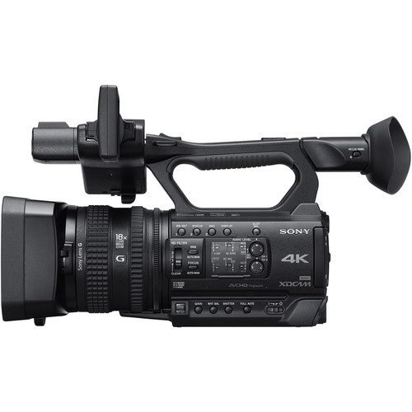 | ea | 3
2 | Camera-Mount Wireless Microphone System  Features: NFC SYNC function for quick and easy secure channel setting (IR sync capability with UTX-B40 transmitter from URX-P03, URX-P03D, and URX-S03D receivers).  True double tuner diversity for stable signal reception  +15 dB gain volume boost mode for off-mic audio  Line input; Channel memory for fast switching between receiver frequencies for two transmitter operations  Headphone output for monitoring; Monitor mode for using a receiver as an ear monitor; Variable muting function; Receiver output level control; High visibility OLED display for indoor/outdoor use; USB connector for power supply.  Item package includes the UTX-B40 body pack transmitter, URX-P40 receiver, ECM-V1BMP microphone and accessories | ea | 4
3 | Professional large diaphragm headphone  Headphone Type: Dynamic, closed Magnet Type: Neodymium; Driver Size: 40.0 mm Frequency Response: 10-20kHz; Impedance: 63 Ohms Sensitivity: 106 dB/W/m; Power Handling: 1,000mW Plug Type: Gold, Stereo Unimatch plug 1/4" and 1/8".  Item package includes: Circumoral Closed-Back Professional Monitor Headphone, Soft Case, - 1/4" Adapter; | ea | 2
4 | Fluid Drag Video Head with Tripod (Twin Legs / Middle Spreader)  A fluid head with a wide platform to support the HDSLR form factor, and a 60mm half ball for quick leveling without adjusting the leg, fluid cartridges on both pan and tilt axes. Support equipment of up to 8 kg and has telescopic aluminum legs for compactness and reduced weight.  Item package includes: Fluid Drag Video Head with MVT502AM Tripod and Carry Bag.  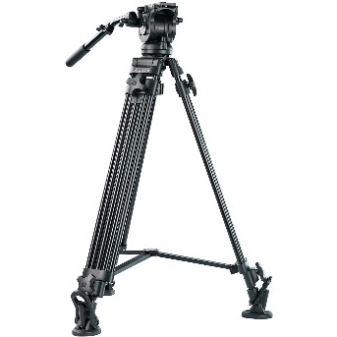 | ea | 3
5 | Audio Project Lone Pine Studio Monitor or equivalent  Monitor Type -Active 2-Way; Low-Mid Driver: 1 x 6.5" / 16.5 cm Woofer Power Rating -80 W; HF Driver: 1 x 1" / 2.5 cm Soft Dome Tweeter; Enclosure -Bass-Reflex; 1 x HF Amplifier: Class-D Rated at 40 W, 1 x Low-Mid Amplifier: Class-AB Rated at 40 W; Frequency Range-39 Hz to 25 kHz (at -10 dB); Frequency Response-45 Hz to 21 kHz ± 3 Db; Maximum Sound Pressure Level (SPL) 112 dB; Total Harmonic Distortion (THD) ≤1.5%; Analog Input Sensitivity/Gain-+4 dBu / -10 dB  Item package includes Audio Project Lone Pine Studio Monitor LP-6 v2 Limited or equivalent  1-Year Warranty | ea | 4
6 | Bluetooth Input Module  2 x XLR and 2 x 1/4" TRS Outputs; Receives CD-Quality Audio over Bluetooth; 3.5mm Mini-Jack Input; Independent Volume Control; LED Indicators | ea | 1
7 | Compact Hybrid Mixer/USB Interface  USB audio interface (24-bit/96 kHz); Cubase LE software included; Cubasis LE App included; 2x mic/line Inputs with separate XLR and TRS jack sockets; 2x stereo inputs with TRS jack sockets; 2x guitar DI high-impedance inputs, eliminating the need for DI boxes; 2x high-pass filters (channels 1 and 2) for cleaning up unwanted low-frequency noise; 2-band EQ on channels 1 through 4 enable tonal shaping; 60mm smooth-travel fader on main mix; 2x XLR main outputs; 8x LED signal metering; 48V Phantom Power for condenser mics; Internal power supply. 1 year guarantee  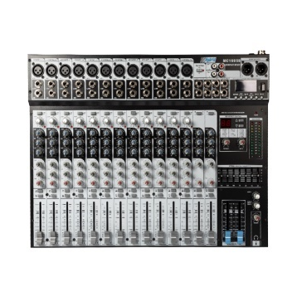 | ea | 1
8 | 4-Channel Digital Video Switcher  Video and embedded audio imported using two HD-SDI and two HDMI inputs.  Multiple video outputs enable to send video to multiple locations. Additional connections for expanding I/O options include 1/4" microphone inputs and analog RCA audio, Ethernet, tally, and USB for firmware updates.  Any Input can be used as a frame (stills) store; Assignable outputs: Program (with DSK), Clean Program (without DSK), Clean Preview (without DSK), Multiview; Frame sync on each input; Flexible mix effects processor with one upstream keyer, supporting chroma key, and linear/luma key; One upstream PiP, supporting chroma key and luma key; Wipe generator: 32 wipe patterns including shapes with border and softness control; Full mix effects preview function; Logo insertion; XPT (Cross Point Assignment); Tally output; Six-channel audio mixer; Supports embedded audio; Multi-language support.  Item package includes: HD 4-Channel Digital Video Switcher, Power Supply.  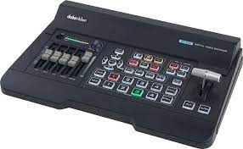 | ea | 1
9 | Design Web Presenter HD  Features: The Web Presenter allows to input any 12G/6G/3G/HD-SDI video source up to UHD 4K; can stream H.264 video via RTMP streaming protocols to the internet via Ethernet or tether a 5G or 4G phone to use mobile data; The built-in USB Type-C input works like a webcam, can connect a computer and use any streaming software; Send program output in 1080p to an HDMI or SDI monitor, or send the original video via an SDI loop output to a monitor or switcher; The graphics-based monitoring output includes a video view, audio meters with accurate ballistics, trend graphs for codec data rates and cache fill, plus a summary of the streaming settings and detailed SDI technical information; The bit activity indicators let see the quality and bit depth of video before H.264 encoding; Audio is de-embedded from the SDI input and the channel status is displayed. The bit activity indicator let check for 16, 20, or 24 bit audio.  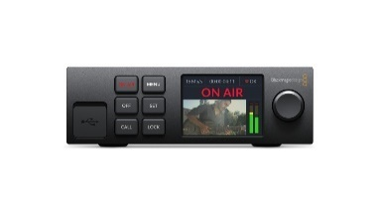 | ea | 1
10 | Mini Converter SDI Distribution  Features: A 1x8 distribution amplifier for SD-SDI, HD-SDI, and 3G-SDI signals; auto-detects the input signal type, re-clocks it, and its eight outputs automatically match the SDI video input; represents an affordable way to distribute SDI signals throughout a facility or truck; supports all SDI-related transmission features, including embedded audio, ancillary data, and the 3 Gb/s transmission rate that accommodates video formats up to 1080p and 2K progressive; handles ASI signals – asynchronous signals that carry multiple compressed programs that can be at varying transmission speeds.  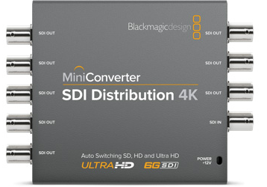 | ea | 1
11 | Mini Converter SDI to HDMI 6G  Features: converts HDMI to SD, HD, 3G, or 6G-SDI in resolutions up to DCI 4K (4096 x 2160) at 24p and UHD 4K (3840 x 2160) up to 30p; using 4K HDMI and 6G-SDI technologies, the Mini Converter automatically detects the input video format and instantly changes between SD, HD, and UHD/DCI 4K formats; supports SD and HD-SDI signals for integration into existing workflows. Both 6G-SDI outputs send duplicate signals; audio is embedded in the SDI output from either the HDMI input or from the two 1/4" input jacks which support four channels of AES/EBU digital audio or two channels of analog audio; The device is powered by an included 12V power supply and includes international socket adapters. | ea | 3
12 | HyperDeck Studio HD Plus or equivalent  Features: The 1 RU tall recorder is 1/2 of a rack wide and powers from 100 to 240 VAC or via an optional 12 VDC power supply for portability. The HyperDeck Studio HD Plus records UHD and DCI 4K video at up to 30 fps. The 6G-SDI outputs allow fill and key playback up to 1080p60; 6G-SDI, and HDMI 2.0 inputs; Two SDI outputs support 1080p60 and 2160p30, and a loop-through output sends the input signal downstream to monitors, switchers, or other devices; The HyperDeck Studio HD Plus supports HDR video and 33-point LUTS on the 3G-SDI output; ProRes: Apple ProRes 422 HQ QuickTime, ProRes 422 QuickTime, ProRes 422 LT QuickTime, ProRes 422 Proxy QuickTime.; DNxHD: DNxHD 220x, DNxHD 220x MXF, DNxHD 145, DNxHD 145 MXF, DNxHD 45, DNxHD 45 MXF for 720p and 1080p HD formats up to 60 fps; H.264: H.264 SDI 4:2:2 10-bit, H.264 High 420 8-bit, H.264 Medium 4:2:0 8-bit, H.264 Low 4:2:0 8-bit for all progressive formats up to 1080p60; Featuring one 6G-SDI input, one HDMI 2.0 input, two 6G-SDI outputs, and one HDMI 2.0 output, this unit is a compact recording/playout powerhouse. A loop-through output and 3G-SDI monitor output as well as reference and timecode in/out, allow this device to fit into a broadcast environment; Two SD card slots allow to capture with virtually unlimited record time, and the unit also supports recording to USB disks via the USB Type-C output port. The HyperDeck Studio HD Plus features a front-panel button control and a jog/shuttle wheel for an analog scrubbing feel. RS-422 control is supported for external control, control the unit using either the USB port or over Ethernet at 1G speeds for faster deck control and file transfers via the RJ45 connector. | ea | 1
13 | The High-Speed HDMI Cable with Ethernet 3m  Features: supports ultrafast speeds, Audio Return Channel, 3D content, and DCI 4K resolution. HDMI Ethernet Channel consolidates video, audio, and data streams into a single HDMI cable. | ea | 6
14 | Desktop Computer  Features: 2.10 GHz Intel Core i7-12700 12-core processor and 16GB of DDR4 RAM. Store applications on the 512GB M.2 SSD and utilize the 1TB 7200 RPM HDD to store media libraries. Streamline workflow by connecting external drives or other accessories to the USB 3.2 Gen 2 and Gen 1 Type-A and Type-C ports. For lower powered accessories such as keyboards and mice, there are four USB Type-A 2.0 ports available. Connect your wireless accessories thanks to Bluetooth 5.2 support, and connect to a wireless network with the integrated Wi-Fi 6. Gigabit Ethernet is available through an RJ-45 port for a stable and fast wired connection. | set | 2
15 | FHD Monitor  23.8" (60.5 cm) Full HD (1920 x 1080) 60Hz IPS LED Backlit LCD / 250 nits / 16:9 / 5 ms / VGA / HDMI / DisplayPort / 4 x USB 3.2 / | ea | 6
16 | Wired Intercom System with Four HP-1 Headsets Kit  Features: kit includes an ITC-100 base station, four MC-1 headsets, four ITC-100SL belt packs, four CB-3 cables (65'/20m), four TD-3 camera tally lights, and four HP-1 single-ear headsets. The ITC-100 system features 8-way talkback and tally indicators that provide clear communication between the director and the camera crew, in production studio and live venue applications. Supports up to 8 wired users; Uses your choice of headsets, from low-cost cell phone sets to high-quality professional units; Uses cables up to 984 ft to connect belt packs.  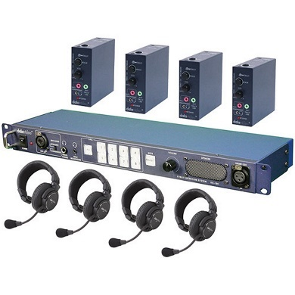 | ea | 1
17 | HD/SD 30m 2-in-1 Cable (HD-SDI/ITC)  HD/SD Video/Tally All-In-One Cable features one SDI cable and one 5-pin XLR tally cable. | ea | 6
18 | Cable reel  Features: Cable Reel with Brake & Reel Lock  25mtr 4 x 230V 2.5mm² Heavy-duty Thermal Trip  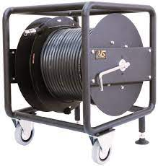 | ea | 3
19 | 4RU Wall Mounted Data Cabinet 600mm X 450mm  Features: 600mm X 450mm Cabinet height: 280mm; Welded frame; Single section, compatible with 19" standard equipment; Tempered glass door; Removable side panel easy to install and maintain; Cable entry top and bottom; L shape mounting profile; Provision for fan mount.  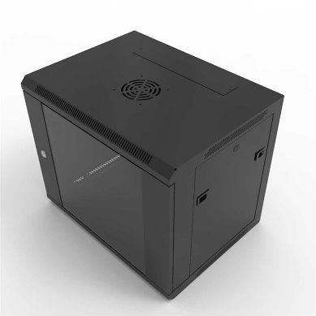 | set | 1
20 | SDXC 128GB Memory Card  Features; Transfer Speeds up to 170 MB/s; Record 4K UHD Video; Rated UHS Speed Class 3 (U3) and Video Speed Class 30 (V30), the SanDisk Extreme PRO UHS-I SDXC card lets you capture sequential burst mode shots. | ea | 8
21 | CFexpress Type A/SD Memory Card Reader  Features: facilitating fast file transfers up to 10 Gb/s, the memory card reader designed specifically for CFexpress Type A memory cards, as well as SD/SDHC/SDXC card types. This reader takes advantage of the card types' fast transfer speeds and allows you to move data over USB 3.1 Gen 2 for post-production editing and file storage. Both USB Type-C to Type-C and USB Type-C to Type-A cables are included. | ea | 2
22 | Wireless microphone set for speech with single receiver and handheld transmitter  Features: Condenser microphone; 120 m Range; 10 h Battery Operation;  Package includes single receiver; handheld transmitter with condenser capsule; microphone clamp; 1 pair detachable antennas; Batteries; Power supply; Rack mount kit.  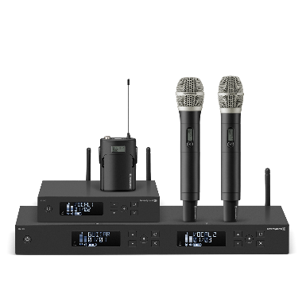 | ea | 2
23 | Wireless Handheld Microphone System  Features: Number of RF Channel Frequencies-1680; Included Transmitters- 1 x Handheld; Diversity-True Diversity; RF Frequency Band-G: 566 to 608 MHz; RF Bandwidth-42 MHz; Frequency Step Size-25 kHz; Max Operating Range-330' / 100.6 m (Line of Sight); Max Transmitters per Band-20; Deviation-±24 kHz (Peak); Modulation- Wideband FM; Receiver Type-Tabletop; Mounting Options-Rackmount (with Included Hardware); Rackmount Size-1 RU (1/2 Rack); Antenna-2 x Rod, Detachable (Rear-Mount); Number of Audio Channels-1; Audio I/O-1 x XLR 3-Pin Male Balanced Output, 1 x 1/4" TRS Female Unbalanced Output; Gain Range-48 dB (3 dB Steps) | ea | 1
24 | Active 6.5" Nearfield Monitor or equivalent  3D Imaging waveguide technology for large, imaginary stereo stages; Bass reflex system; Boundary EQ to adjust the sound in different studio environments; Power: 80 W (40 W / 40 W bi-amped); Speaker configuration: 6.5" woofer with reduced mass, 1" soft dome tweeter; Frequency range: 39 - 25,000 Hz; Crossover frequency: 1300 Hz; Sound pressure level: 85 dB SPL continuous; Inputs: XLR, 6.3 mm jack (balanced), Cinch; Input sensitivity XLR / 6.3 mm jack: +; 4 dBu; Input sensitivity RCA: -10 dBV | ea | 2
25 | Radio automation software  Features: produce professional, sophisticated audio programming for a fraction of the cost of other radio programming applications. Robust support for Internet broadcasters. Built-in support for Internet streaming (Shoutcast v1, v2, Icecast, Windows Media Services), automatically sending metadata (upload to FTP, HTTP request, text or XML file) and using streamed Internet audio in playlists; work with audio formats, Winamp and VST plugins, multichannel cards (4.0, 5.1, 7.1 etc), individualized RadioBOSS profiles or equivalent | ea | 2
26 | Condenser microphone  Features: Suitable for, broadcast applications, universal use for room milking ; extended and balanced frequency response; Integrated elastic system suspension; Polar pattern: Cardioid; 34 mm true condenser capsule; Phantom power supply: 20 - 52 V; Operating principle: Pressure gradient receiver; Frequency range: 20 - 20.000 Hz; Nominal impedance: 180 Ohm; Max. sound pressure level (at 1 kHz): 133 dB; Very low inherent noise of 5.6 dB; Open circuit voltage at 1 kHz (0 dB = 1 V/Pa): 36.3 mV/Pa (-28.8 dBV ±2 dB); 3-pin male XLR connector  Package includes . Elastic mount, studio pop filter with gooseneck and bag.  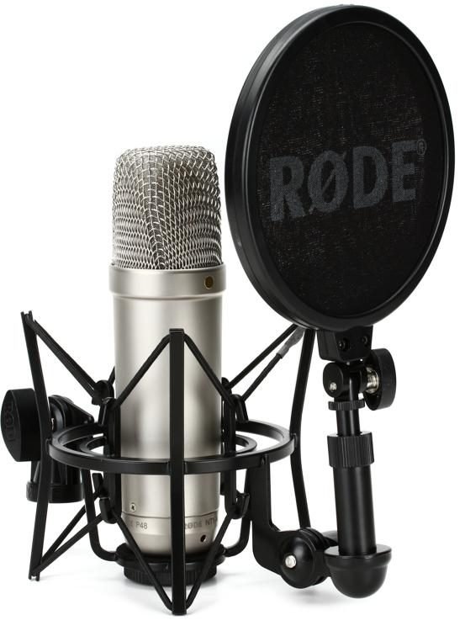 | ea | 1
27 | Microphone Gooseneck Stand  Plastic and metal; flexible – Sturdy and Convenient gooseneck stands for use with most microphones.  Adjustable – Always get the perfect recording angle with this adjustable stand; Hands free recording – Free your hands from your dictation microphone with this premium holder; Solid base – Cast iron microphone base to keep your microphone in place all the time. Includes 1 Microphone Holder, 2 Screws and 2 Wingnuts; wide compatibility – Compatible with speech mike Air.  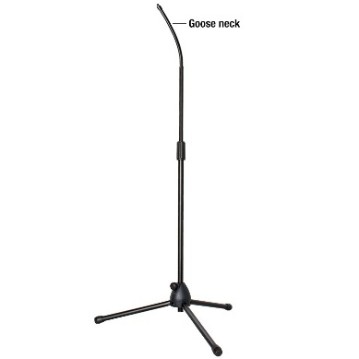 | ea | 1
28 | USB Audio Interface  Features: USB Audio Interface, 2-in/2-out, with 2 Mic/Line/Instrument Preamps, 4K Legacy Mode, USB Bus Power, and Bundled Software - Mac/Win; Computer Connectivity:USB 2.0; Form Factor:Desktop; Simultaneous I/O:2 x 2; Number of Preamps:2; Phantom Power:Yes; A/D Resolution:24-bit/192kHz; Analog Inputs:2 x XLR-1/4" combo (mic/line/Hi-Z); Analog Outputs:2 x 1/4" TRS (L/R); Headphones:1 x 1/4"; USB:1 x USB-C; Software:SSL Production Pack, 3rd Party Bundled Software; OS Requirements - Mac:OS X 10.11 ; OS Requirements - PC:Windows 8.1; us Powered:Yes; Power Supply:USB bus powered. | ea | 1
29 | 250 Ohm Over-Ear Studio Headphones  Features: Diffuse-field equalized; Closed-back; Circumoral design; Dynamic; Impedance: 250 Ohm; Sensitivity SPL (sound pressure level): 96 dB; Frequency response: 5 - 35,000 Hz; 3 m Coiled cable with 3.5 mm connector  Screwable adapter to 6.3 mm stereo jack.  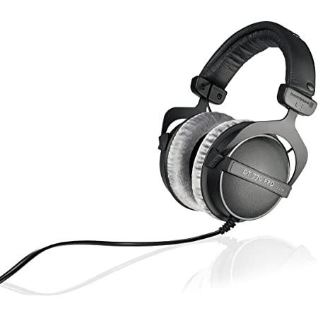 | ea | 4
30 | Microphone Stand with Folding Tripod Base and 2-Point Adjustment Telescoping Boom  Features: Tubing material-Steel; Tubing surface-Powder coated; Min. height-1030 mm; Max. height  1690 mm; Transport length-1050 mm; Height adjustment; Base type-Tripod; Base material-Zinc die-cast;  Boom model-2-point adjustment; Boom length-880 mm; Interchangeable rings-1 x 25 mm, 2 x 15 mm, 4 x 20 mm  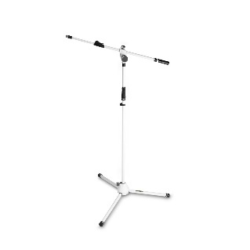 | ea | 3
31 | Gravity Folding Stand Neck Holder  Material: Steel; Colour: Black; Surface: powder-coated; Suitable for: for use in bands; Black Ring Set  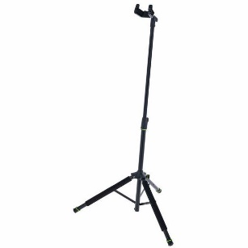 | ea | 1
32 | Super-bright Soft Panel LED Light  Features: 150W Ultra Bright Panel Light 2700K-6500K, 5500Lux, V-Mount, DMX, ideal for 4K shooting).; Bi-color SMD LED panel light with high intensity, smooth dimmer curve, high CRI/TLCI/SSI, for both broadcast studio and field setup; 5500Lux@1m Super Bright; Non-linear Dimming Curve; non-linear index dimming curver, and the 1% dimmer equals to only 0.3% of the full intensity, to match with the sensitivity of human eyes; No Fan, No Noise  Package includes: Swit PL-S150D LED Light; 2x Safety rope; 1x AC-DC Adaptor; 1x Barn door kit. | ea | 4
33 | Bi-colour Portable LED Spot Light  Features: portable LED spot light adopts Chip-On-Board LEDs of 50,000 hours lifetime, 60W power, bi-color, DMX adjusting focus angle, as the key light of interview light kit or field video productions; 2700K-8000K DMX Support.; super bright and long-life COB-LED; Spot /Flood Adjust  15° - 60° Electromotion/DMX adjust; outputs 15° - 60° beam angle adjusting by Electromotion knob or DMX. The illuminance is as high as 25000Lux @ 1 meter. The following output illuminances at different distances are for reference: Distance / 15° Spot / 60° Flood; 1 meters, 25000Lux, 4000Lux; 2 meters, 6250Lux, 1000Lux; 3 meters, 2700Lux, 445Lux; Bi-colour temperature  2700K-8000K continuously adjustable  Package includes: 1x FL-C60D Light; 1x AC-DC Power adaptor; 1x Light Stand Battery plate;1x D-tap to 4-pin XLR DC cable.  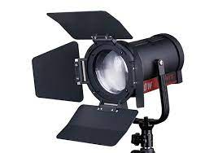 | ea | 1
34 | Light/Tripod/Case Kit  Features: Portable LED spot light adopts Chip-On-Board LEDs of 50,000 hours lifetime, 60W power, bi-colour, DMX adjusting focus angle, as the key light of interview light kit or field video productions; Spot /Flood Adjust-15° - 60° Electromotion/DMX ; FL-C60D outputs 15° - 60° beam angle adjusting by Electromotion knob or DMX. The illuminance is as high as 25000Lux at 1 meter.  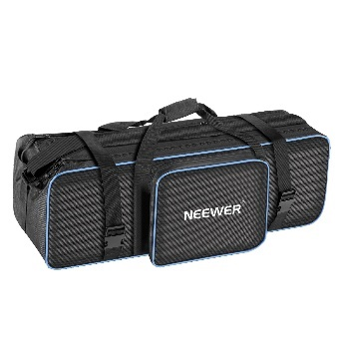 | kit | 1
35 | Bi-colour temperature-2700K-8000K continuously adjustable  3 x FL-C60D Light; 3 x Light Stand Tripod; 3 x AC-DC Power Adaptor; 3 x S-7200S V-Mount Plate W/ Clamp; 3 x S-7101 D-Tap to 4-Pin Cable; 1 x Trolley Case. | ea | 4
36 | Bi-Color Studio LED Spot Light  Features: 160W Bi-Color Studio LED Spot Light LED overheat detection and protection; is a studio LED spot light, with Chip-on-board LEDs of 50,000 hours lifetime, and generates 160W light output, which is a useful light source for broadcast studio and field video productions ; adopts standard 5-pin DMX in/out port, supports DMX512 protocol, and adjusts dimmer and color temperature by DMX controller. The dimmer and color temperature occupy 1 DMX address respectively. The DMX address is set by 10x binary DIP switchers, and displayed by LED; The rear LCD screen can display the current dimmer percentage, color temperature value, and supports touch control to adjust; adopts silent fans to radiate heat, which will not affect normal shooting environment to record audio. While in strictly silent required broadcast environment, S-2320 can be switched to "Silent Mode" to turn off the fans. And meanwhile, the max brightness will be reduced to 50%; supports Sleep Mode: you can switch off the light by pressing the DIMMER knob, to enter Sleep Mode. And press the DIMMER knob again; the S-2320 can be quickly light up to the previous dimmer value; equipped with 4-leaf metal barndoors, removable and rotatable. Meanwhile, the light provides a special black-out cloth to prevent the light leakage.  Package includes: SWIT S-2320 160W Bi-Color Studio LED Spot Light; U-shape bracket; Barndoors  Black-Out Cloth; AC Power Cable - 4m  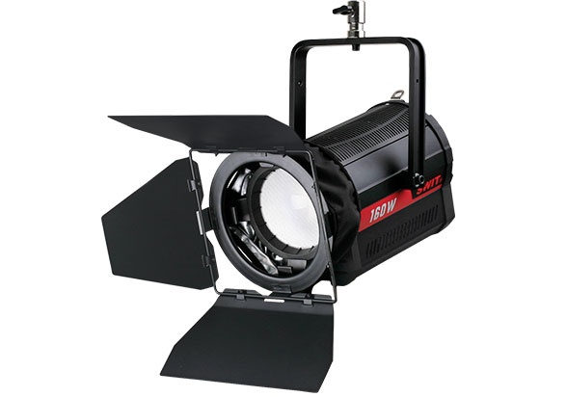 | ea | 4
37 | Wireless DMX receiver  Features: wireless receiver for controlling a variety of lights via DMX512. Requires the wireless 8-channel DMX transmitter; Controllable via license-free 2.4 GHz radio frequency; One colored LED per active group (on transmitter and receiver); Several receivers controllable with one transmitter; Operation via Micro-USB  Reception Range (via transmitter): up to 400 m (line of sight); Rotation Angle: approx. 300°  1x Connection via 5-pin XLR; 1x Power supply IN via Micro-USB;The receiver is operated via Micro-USB with 5 Volt. Compatible with a wide range of DMX-capable lights  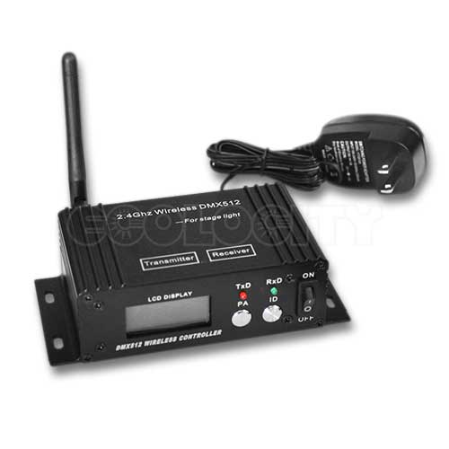 | ea | 5
38 | Pocket Wireless DMX Controller Kit  Features: portable wireless DMX controller for field light kit application, compatible with all standard DMX512 protocol lights, to get rid of complex DMX cable work and large DMX console, and makes the field light kit control easier and quicker; Pocket size portable DMX controller;2.4G wireless, quick connection; 400m (LOS) transmission distance; Control all standard DMX512 lights  8-ch x 7 groups control channels;2x AA batteries or USB power; The Controller can be powered by 2x AA batteries, continuously 4 hours working. Support sleep mode if no operation after 1 minute.  The Controller supports Micro USB power input as well.; The Light Adaptor is powered by USB, only 0.5W power;  Package includes: 1x LA-WR8 controller; 3x LA-WR8-R light adaptors; 3x Micro USB power cables for light adaptor.  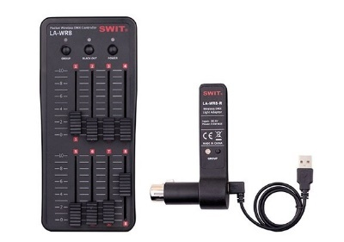 | ea | 1
39 | Green Chromakey  Features: Panoramic Background 4m Chromakey Green is a collapsible 4m (13’) wide, 2.3m (7’5”) high background that folds down neatly into its own carry cas. Weigh 9kg ; The background is completely self-supporting and can be set up in minutes. The structure comprises three individual aluminium framed sections, connected together with a hinge clip to allow the background to be set up flat to lean against a wall or with the side frames folded in to create a wraparound effect. The Chroma Key Green cover just simply clips to the aluminum frame and creates a taught, seamless surface.  Package: Panoramic Background Chroma Key Green; Storage Case for Frame. | ea | 1
40 | LED TV 32  Smart TV with Universal Guide; Bixby Voice, 100% Color Volume with Quantum Dot; 4K UHD Processor; HDR  144Hz 4K and 8K sets  QUANTUM HDR | ea | 2
41 | Bluetooth Hand Controller  Bluetooth Hand Controller features an easy-to-use 4-button design. The buttons on the hand controller let you arrange the speed of the text, skip to the next message, go back to the previous texts, and go to the top and end of the pages. | ea | 1
42 | Tablet Prompter  Features: The prompter features a 70/30 beam splitter glass for a clear and bright image, and it has an 11.5' reading range for your talent; tablet's built-in Bluetooth connectivity allows you to control your prompter from a Bluetooth mouse and keyboard; supports DSLRs, mirrorless, and small ENG cameras weighing up to 5.5 pounds. Package includes: Fortinge NOA Tablet Prompter; 70/30 Beamsplitter Glass; Support Rods  Hood; Tablet Holder; Camera Plate  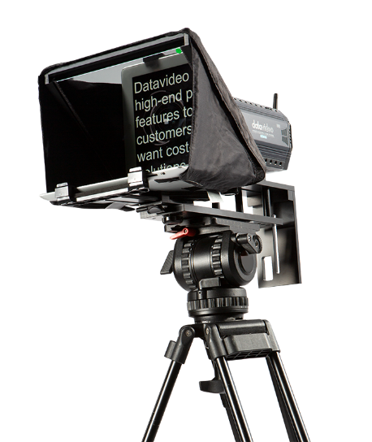 | ea | 1
43 | Batteries AA rechargeable  Features: Battery size: AA Batteries; Capacity: 2600mAH; Voltage: 1.2V; Battery technology: NiMH | ea | 20
44 | Batteries AA charger  Compatibility- AAA, Micro; AA, Mignon; Charging slots:2/4x AAA; 2/4x AA; Battery System-Nickel Metal Hydride (NiMH); Charging time-5 h (based on 4x AA 1600 mAh); Charging current: AAA150 mA AA350 mA | ea | 3
45 | SINGLE CIRCUIT TRACK LIGHTING  This single circuit track shall be rolled to create curves or a circular track system. A range of advanced mains track fittings with a track galvanized pipe of d50 mm. This shall be suspended from the ceiling with the appropriate fixings, using components that affix around the track thereby providing a secure installation. | ea | 1
46 | Cable Trays, Trucking and Accessories  Cable tray is assembly of units and associated fittings forming a rigid structural system which can securely support insulated electrical cables used for power distribution, control and communication.  The products will be used to equip 150 sq/m of the studio.  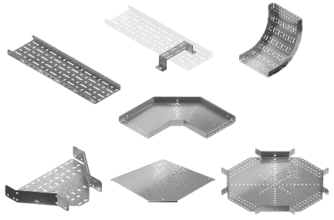
47 | Heavy Velvet Flat Hooks Curtains Soundproof Drapes with Blackout Lining  (Installation of Velvet Flat Hooks Curtains to absorb and dampen sound, including cornice, installation accessories and installation of cornice and curtains)  Material: Velvet  Color: Black or Brown (#18)-blackout Lining  Top Style: Back Tab, Grommet, Rod Pocket, Tab Top  Size: (250Wx102L) *1  Thermal insulated  Blocking 85-95% of sunlight  Noise reduction  Room divider  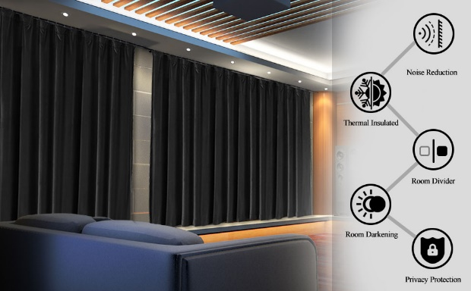
48 | Installation of all equipment listed above
49 | Training for 15 days for 10 participants from VET center
50 | Transportation and other cost
Unexpected expenses xx %
TOTAL

Delivery Requirements

Delivery Requirements
Delivery date and time | Bidder shall handover all works at latest end of July, 2022
Delivery Terms (INCOTERMS 2020) | DAP
Customs clearance (must be linked to INCOTERM | Shall be done by:  - Name of organisation (where applicable)  - Supplier/bidder with the help of UNDP  - Freight Forwarder
Exact Address(es) of Delivery Location(s) | Address:  Alijabbar Orucaliyev 69, Baku, Narimanov rayon
Distribution of shipping documents (if using  freight forwarder) | N/A
Packing Requirements | N/A
Training on Operations  and Maintenance | N/A
Warranty Period | 1-year standard manufacturing warranty for the goods and services
After-sales service and local service support  requirements | N/A
Preferred Mode of Transport | N/A

ANNEX 2: QUOTATION SUBMISSION FORM
Bidders are requested to complete this form, including the Company Profile and Bidder’s Declaration, sign it and return it as part of their quotation along with Annex 3: Technical and Financial Offer. The Bidder shall fill in this form in accordance with the instructions indicated. No alterations to its format shall be permitted and no substitutions shall be accepted.

Name of Bidder: | Click or tap here to enter text.
RFQ reference: | Click or tap here to enter text. | Date: Click or tap to enter a date.

Company Profile

Item Description | Detail
Legal name of bidder or Lead entity for JVs | Click or tap here to enter text.
Legal Address, City, Country | Click or tap here to enter text.
Website | Click or tap here to enter text.
Year of Registration | Click or tap here to enter text.
Legal structure | Choose an item.
Are you a UNGM registered vendor? | - Yes ☐ No If yes, insert UNGM Vendor Number
Quality Assurance Certification (e.g. ISO 9000 or Equivalent) (If yes, provide a Copy of the valid Certificate): | - Yes ☐ No
Does your Company hold any accreditation such as ISO 14001 or ISO 14064 or equivalent related to the environment? (If yes, provide a Copy of the valid Certificate): | - Yes ☐ No
Does your Company have a written Statement of its Environmental Policy? (If yes, provide a Copy) | - Yes ☐ No
Does your organization demonstrate significant commitment to sustainability through some other means, for example internal company policy documents on women empowerment, renewable energies or membership of trade institutions promoting such issues (If yes, provide a Copy) | - Yes ☐ No

Is your company a member of the UN Global Compact |  | - Yes ☐ No
Bank Information |  | Bank Name: Click or tap here to enter text. Bank Address: Click or tap here to enter text. IBAN: Click or tap here to enter text.  SWIFT/BIC: Click or tap here to enter text. Account Currency: Click or tap here to enter text.  Bank Account Number: Click or tap here to enter text.
Previous relevant experience: 3 contracts
Name of previous contracts | Client & Reference  Contact Details including e-mail |  | Contract Value | Period of activity | Types of activities undertaken

Bidder’s Declaration

Yes | No
☐ | ☐ | Requirements and Terms and Conditions: I/We have read and fully understand the RFQ, including the RFQ Information and Data, Schedule of Requirements, the General Conditions of Contract, and any Special Conditions of Contract. I/we confirm that the Bidder agrees to be bound by them.
☐ | ☐ | I/We confirm that the Bidder has the necessary capacity, capability, and necessary licenses to fully meet or exceed the Requirements and will be available to deliver throughout the relevant Contract period.
☐ | ☐ | Ethics: In submitting this Quote I/we warrant that the bidder: has not entered into any improper, illegal, collusive or anti-competitive arrangements with any Competitor; has not directly or indirectly approached any representative of the Buyer (other than the Point of Contact) to lobby or solicit information in relation to the RFQ ;has not attempted to influence, or provide any form of personal inducement, reward or benefit to any representative of the Buyer.
☐ | ☐ | I/We confirm to undertake not to engage in proscribed practices, , or any other unethical practice, with the UN or any other party, and to conduct business in a manner that averts any financial, operational, reputational or other undue risk to the UN and we have read the United Nations Supplier Code of Conduct :https://www.un.org/Depts/ptd/about-us/un-supplier-code-conduct and acknowledge that it  provides the minimum standards expected of suppliers to the UN.
☐ | ☐ | Conflict of interest: I/We warrant that the bidder has no actual, potential, or perceived Conflict of Interest in submitting this Quote or entering a Contract to deliver the Requirements. Where a Conflict of Interest arises during the RFQ process the bidder will report it immediately to the Procuring  Organisation’s Point of Contact.
☐ | ☐ | Prohibitions, Sanctions: l/We hereby declare that our firm, its affiliates or subsidiaries or employees, including any JV/Consortium members or subcontractors or suppliers for any part of the contract is not under procurement prohibition by the United Nations, including but not limited to prohibitions derived from the Compendium of United Nations Security Council Sanctions Lists and have not been suspended, debarred, sanctioned or otherwise identified as ineligible by any UN Organization or the World Bank Group or any other international Organization.
☐ | ☐ | Bankruptcy: l/We have not declared bankruptcy, are not involved in bankruptcy or receivership proceedings, and there is no judgment or pending legal action against them that could impair their  operations in the foreseeable future.

Yes | No
☐ | ☐ | Offer Validity Period: I/We confirm that this Quote, including the price, remains open for acceptance for the Offer Validity.
☐ | ☐ | I/We understand and recognize that you are not bound to accept any Quotation you receive, and we  certify that the goods offered in our Quotation are new and unused.
☐ | ☐ | By signing this declaration, the signatory below represents, warrants and agrees that he/she has been authorised by the Organization/s to make this declaration on its/their behalf.

Signature: Name: Click or tap here to enter text.
Title: Click or tap here to enter text. Date: Click or tap to enter a date

ANNEX 3: TECHNICAL AND FINANCIAL OFFER - GOODS
Bidders are requested to complete this form, sign it and return it as part of their bid along with Annex 2: Quotation Submission Form. The Bidder shall fill in this form in accordance with the instructions indicated. No alterations to its format shall be permitted and no substitutions shall be accepted.

Name of Bidder: | Click or tap here to enter text.
RFQ reference: | Click or tap here to enter text. | Date: Click or tap to enter a date.

VET Center N5 on Art and Culture
№ | List of equipment | Unit | Quantity | Price per item | Final price for product in USD
1 | 4K XDCAM Camcorder  Features: A single Exmor RS sensor with a UHD 4K (3840 x 2160) resolution, G lens with 12x optical zoom range, and 18/24x Clear Image Zoom in 4K/HD. Recording 4K in XAVC Long at 4:2:0 8-bit, and HD in XAVC Long at 4:2:2 10-bit, as well as MPEG2HD at 4:2:2 or 4:2:0 in 8-bit only.  Recording to a variety of formats: 100 Mb/s XAVC Long GOP recording of 4K UHD video at up to 29.97p, HD up to 59.94p, MPEG HD up to 59.94p, and AVCHD 2.0 up to 59.94p.  Footage is recorded to media via two SD memory card slots. It features built-in Wi-Fi and NFC connectivity, two 3-pin XLR audio inputs that support line, mic, and mic + 48V (phantom power) for using external microphones and Night Shot capability.  Item package includes: 4K XDCAM Camcorder; Lens Hood; Large Eyecup; Shoe Cap; Accessory Shoe Kit (1x Accessory Shoe, 1x Accessory Shoe Plate, 4x Screws); USB Cable; AC-L100 AC Adapter; AC Cable; NP-F770 L-Series Info-Lithium Battery Pack (7.2v, 4400mAh); Battery Charger; Infrared Remote Commander (RMT-845); CR2025 Lithium Battery (Pre-Installed in IR Remote Commander) | ea | 3
2 | Camera-Mount Wireless Microphone System  Features: NFC SYNC function for quick and easy secure channel setting (IR sync capability with UTX-B40 transmitter from URX-P03, URX-P03D, and URX-S03D receivers).  True double tuner diversity for stable signal reception  +15 dB gain volume boost mode for off-mic audio  Line input; Channel memory for fast switching between receiver frequencies for two transmitter operations  Headphone output for monitoring; Monitor mode for using a receiver as an ear monitor; Variable muting function; Receiver output level control; High visibility OLED display for indoor/outdoor use; USB connector for power supply.  Item package includes the UTX-B40 body pack transmitter, URX-P40 receiver, ECM-V1BMP microphone and accessories | ea | 4
3 | Professional large diaphragm headphone  Headphone Type: Dynamic, closed Magnet Type: Neodymium; Driver Size: 40.0 mm Frequency Response: 10-20kHz; Impedance: 63 Ohms Sensitivity: 106 dB/W/m; Power Handling: 1,000mW Plug Type: Gold, Stereo Unimatch plug 1/4" and 1/8".  Item package includes: Circumoral Closed-Back Professional Monitor Headphone, Soft Case, - 1/4" Adapter; | ea | 2
4 | Fluid Drag Video Head with Tripod (Twin Legs / Middle Spreader)  A fluid head with a wide platform to support the HDSLR form factor, and a 60mm half ball for quick leveling without adjusting the leg, fluid cartridges on both pan and tilt axes. Support equipment of up to 8 kg and has telescopic aluminum legs for compactness and reduced weight.  Item package includes: Fluid Drag Video Head with MVT502AM Tripod and Carry Bag. | ea | 3
5 | Audio Project Lone Pine Studio Monitor or equivalent  Monitor Type -Active 2-Way; Low-Mid Driver: 1 x 6.5" / 16.5 cm Woofer Power Rating -80 W; HF Driver: 1 x 1" / 2.5 cm Soft Dome Tweeter; Enclosure -Bass-Reflex; 1 x HF Amplifier: Class-D Rated at 40 W, 1 x Low-Mid Amplifier: Class-AB Rated at 40 W; Frequency Range-39 Hz to 25 kHz (at -10 dB); Frequency Response-45 Hz to 21 kHz ± 3 Db; Maximum Sound Pressure Level (SPL) 112 dB; Total Harmonic Distortion (THD) ≤1.5%; Analog Input Sensitivity/Gain-+4 dBu / -10 dB  Item package includes Audio Project Lone Pine Studio Monitor LP-6 v2 Limited or equivalent  1-Year Warranty | ea | 4
6 | Bluetooth Input Module  2 x XLR and 2 x 1/4" TRS Outputs; Receives CD-Quality Audio over Bluetooth; 3.5mm Mini-Jack Input; Independent Volume Control; LED Indicators | ea | 1
7 | Compact Hybrid Mixer/USB Interface  USB audio interface (24-bit/96 kHz); Cubase LE software included; Cubasis LE App included; 2x mic/line Inputs with separate XLR and TRS jack sockets; 2x stereo inputs with TRS jack sockets; 2x guitar DI high-impedance inputs, eliminating the need for DI boxes; 2x high-pass filters (channels 1 and 2) for cleaning up unwanted low-frequency noise; 2-band EQ on channels 1 through 4 enable tonal shaping; 60mm smooth-travel fader on main mix; 2x XLR main outputs; 8x LED signal metering; 48V Phantom Power for condenser mics; Internal power supply. 1 year guarantee | ea | 1
8 | 4-Channel Digital Video Switcher  Video and embedded audio imported using two HD-SDI and two HDMI inputs.  Multiple video outputs enable to send video to multiple locations. Additional connections for expanding I/O options include 1/4" microphone inputs and analog RCA audio, Ethernet, tally, and USB for firmware updates.  Any Input can be used as a frame (stills) store; Assignable outputs: Program (with DSK), Clean Program (without DSK), Clean Preview (without DSK), Multiview; Frame sync on each input; Flexible mix effects processor with one upstream keyer, supporting chroma key, and linear/luma key; One upstream PiP, supporting chroma key and luma key; Wipe generator: 32 wipe patterns including shapes with border and softness control; Full mix effects preview function; Logo insertion; XPT (Cross Point Assignment); Tally output; Six-channel audio mixer; Supports embedded audio; Multi-language support.  Item package includes: HD 4-Channel Digital Video Switcher, Power Supply. | ea | 1
9 | Design Web Presenter HD  Features: The Web Presenter allows to input any 12G/6G/3G/HD-SDI video source up to UHD 4K; can stream H.264 video via RTMP streaming protocols to the internet via Ethernet or tether a 5G or 4G phone to use mobile data; The built-in USB Type-C input works like a webcam, can connect a computer and use any streaming software; Send program output in 1080p to an HDMI or SDI monitor, or send the original video via an SDI loop output to a monitor or switcher; The graphics-based monitoring output includes a video view, audio meters with accurate ballistics, trend graphs for codec data rates and cache fill, plus a summary of the streaming settings and detailed SDI technical information; The bit activity indicators let see the quality and bit depth of video before H.264 encoding; Audio is de-embedded from the SDI input and the channel status is displayed. The bit activity indicator let check for 16, 20, or 24 bit audio. | ea | 1
10 | Mini Converter SDI Distribution  Features: A 1x8 distribution amplifier for SD-SDI, HD-SDI, and 3G-SDI signals; auto-detects the input signal type, re-clocks it, and its eight outputs automatically match the SDI video input; represents an affordable way to distribute SDI signals throughout a facility or truck; supports all SDI-related transmission features, including embedded audio, ancillary data, and the 3 Gb/s transmission rate that accommodates video formats up to 1080p and 2K progressive; handles ASI signals – asynchronous signals that carry multiple compressed programs that can be at varying transmission speeds. | ea | 1
11 | Mini Converter SDI to HDMI 6G  Features: converts HDMI to SD, HD, 3G, or 6G-SDI in resolutions up to DCI 4K (4096 x 2160) at 24p and UHD 4K (3840 x 2160) up to 30p; using 4K HDMI and 6G-SDI technologies, the Mini Converter automatically detects the input video format and instantly changes between SD, HD, and UHD/DCI 4K formats; supports SD and HD-SDI signals for integration into existing workflows. Both 6G-SDI outputs send duplicate signals; audio is embedded in the SDI output from either the HDMI input or from the two 1/4" input jacks which support four channels of AES/EBU digital audio or two channels of analog audio; The device is powered by an included 12V power supply and includes international socket adapters. | ea | 3
12 | HyperDeck Studio HD Plus or equivalent  Features: The 1 RU tall recorder is 1/2 of a rack wide and powers from 100 to 240 VAC or via an optional 12 VDC power supply for portability. The HyperDeck Studio HD Plus records UHD and DCI 4K video at up to 30 fps. The 6G-SDI outputs allow fill and key playback up to 1080p60; 6G-SDI, and HDMI 2.0 inputs; Two SDI outputs support 1080p60 and 2160p30, and a loop-through output sends the input signal downstream to monitors, switchers, or other devices; The HyperDeck Studio HD Plus supports HDR video and 33-point LUTS on the 3G-SDI output; ProRes: Apple ProRes 422 HQ QuickTime, ProRes 422 QuickTime, ProRes 422 LT QuickTime, ProRes 422 Proxy QuickTime.; DNxHD: DNxHD 220x, DNxHD 220x MXF, DNxHD 145, DNxHD 145 MXF, DNxHD 45, DNxHD 45 MXF for 720p and 1080p HD formats up to 60 fps; H.264: H.264 SDI 4:2:2 10-bit, H.264 High 420 8-bit, H.264 Medium 4:2:0 8-bit, H.264 Low 4:2:0 8-bit for all progressive formats up to 1080p60; Featuring one 6G-SDI input, one HDMI 2.0 input, two 6G-SDI outputs, and one HDMI 2.0 output, this unit is a compact recording/playout powerhouse. A loop-through output and 3G-SDI monitor output as well as reference and timecode in/out, allow this device to fit into a broadcast environment; Two SD card slots allow to capture with virtually unlimited record time, and the unit also supports recording to USB disks via the USB Type-C output port. The HyperDeck Studio HD Plus features a front-panel button control and a jog/shuttle wheel for an analog scrubbing feel. RS-422 control is supported for external control, control the unit using either the USB port or over Ethernet at 1G speeds for faster deck control and file transfers via the RJ45 connector. | ea | 1
13 | The High-Speed HDMI Cable with Ethernet 3m  Features: supports ultrafast speeds, Audio Return Channel, 3D content, and DCI 4K resolution. HDMI Ethernet Channel consolidates video, audio, and data streams into a single HDMI cable. | ea | 6
14 | Desktop Computer  Features: 2.10 GHz Intel Core i7-12700 12-core processor and 16GB of DDR4 RAM. Store applications on the 512GB M.2 SSD and utilize the 1TB 7200 RPM HDD to store media libraries. Streamline workflow by connecting external drives or other accessories to the USB 3.2 Gen 2 and Gen 1 Type-A and Type-C ports. For lower powered accessories such as keyboards and mice, there are four USB Type-A 2.0 ports available. Connect your wireless accessories thanks to Bluetooth 5.2 support, and connect to a wireless network with the integrated Wi-Fi 6. Gigabit Ethernet is available through an RJ-45 port for a stable and fast wired connection. | set | 2
15 | FHD Monitor  23.8" (60.5 cm) Full HD (1920 x 1080) 60Hz IPS LED Backlit LCD / 250 nits / 16:9 / 5 ms / VGA / HDMI / DisplayPort / 4 x USB 3.2 / | ea | 6
16 | Wired Intercom System with Four HP-1 Headsets Kit  Features: kit includes an ITC-100 base station, four MC-1 headsets, four ITC-100SL belt packs, four CB-3 cables (65'/20m), four TD-3 camera tally lights, and four HP-1 single-ear headsets. The ITC-100 system features 8-way talkback and tally indicators that provide clear communication between the director and the camera crew, in production studio and live venue applications. Supports up to 8 wired users; Uses your choice of headsets, from low-cost cell phone sets to high-quality professional units; Uses cables up to 984 ft to connect belt packs. | ea | 1
17 | HD/SD 30m 2-in-1 Cable (HD-SDI/ITC)  HD/SD Video/Tally All-In-One Cable features one SDI cable and one 5-pin XLR tally cable. | ea | 6
18 | Cable reel  Features: Cable Reel with Brake & Reel Lock  25mtr 4 x 230V 2.5mm² Heavy-duty Thermal Trip | ea | 3
19 | 4RU Wall Mounted Data Cabinet 600mm X 450mm  Features: 600mm X 450mm Cabinet height: 280mm; Welded frame; Single section, compatible with 19" standard equipment; Tempered glass door; Removable side panel easy to install and maintain; Cable entry top and bottom; L shape mounting profile; Provision for fan mount. | set | 1
20 | SDXC 128GB Memory Card  Features; Transfer Speeds up to 170 MB/s; Record 4K UHD Video; Rated UHS Speed Class 3 (U3) and Video Speed Class 30 (V30), the SanDisk Extreme PRO UHS-I SDXC card lets you capture sequential burst mode shots. | ea | 8
21 | CFexpress Type A/SD Memory Card Reader  Features: facilitating fast file transfers up to 10 Gb/s, the memory card reader designed specifically for CFexpress Type A memory cards, as well as SD/SDHC/SDXC card types. This reader takes advantage of the card types' fast transfer speeds and allows you to move data over USB 3.1 Gen 2 for post-production editing and file storage. Both USB Type-C to Type-C and USB Type-C to Type-A cables are included. | ea | 2
22 | Wireless microphone set for speech with single receiver and handheld transmitter  Features: Condenser microphone; 120 m Range; 10 h Battery Operation;  Package includes single receiver; handheld transmitter with condenser capsule; microphone clamp; 1 pair detachable antennas; Batteries; Power supply; Rack mount kit. | ea | 2
23 | Wireless Handheld Microphone System  Features: Number of RF Channel Frequencies-1680; Included Transmitters- 1 x Handheld; Diversity-True Diversity; RF Frequency Band-G: 566 to 608 MHz; RF Bandwidth-42 MHz; Frequency Step Size-25 kHz; Max Operating Range-330' / 100.6 m (Line of Sight); Max Transmitters per Band-20; Deviation-±24 kHz (Peak); Modulation- Wideband FM; Receiver Type-Tabletop; Mounting Options-Rackmount (with Included Hardware); Rackmount Size-1 RU (1/2 Rack); Antenna-2 x Rod, Detachable (Rear-Mount); Number of Audio Channels-1; Audio I/O-1 x XLR 3-Pin Male Balanced Output, 1 x 1/4" TRS Female Unbalanced Output; Gain Range-48 dB (3 dB Steps) | ea | 1
24 | Active 6.5" Nearfield Monitor or equivalent  3D Imaging waveguide technology for large, imaginary stereo stages; Bass reflex system; Boundary EQ to adjust the sound in different studio environments; Power: 80 W (40 W / 40 W bi-amped); Speaker configuration: 6.5" woofer with reduced mass, 1" soft dome tweeter; Frequency range: 39 - 25,000 Hz; Crossover frequency: 1300 Hz; Sound pressure level: 85 dB SPL continuous; Inputs: XLR, 6.3 mm jack (balanced), Cinch; Input sensitivity XLR / 6.3 mm jack: +; 4 dBu; Input sensitivity RCA: -10 dBV | ea | 2
25 | Radio automation software  Features: produce professional, sophisticated audio programming for a fraction of the cost of other radio programming applications. Robust support for Internet broadcasters. Built-in support for Internet streaming (Shoutcast v1, v2, Icecast, Windows Media Services), automatically sending metadata (upload to FTP, HTTP request, text or XML file) and using streamed Internet audio in playlists; work with audio formats, Winamp and VST plugins, multichannel cards (4.0, 5.1, 7.1 etc), individualized RadioBOSS profiles or equivalent | ea | 2
26 | Condenser microphone  Features: Suitable for, broadcast applications, universal use for room milking ; extended and balanced frequency response; Integrated elastic system suspension; Polar pattern: Cardioid; 34 mm true condenser capsule; Phantom power supply: 20 - 52 V; Operating principle: Pressure gradient receiver; Frequency range: 20 - 20.000 Hz; Nominal impedance: 180 Ohm; Max. sound pressure level (at 1 kHz): 133 dB; Very low inherent noise of 5.6 dB; Open circuit voltage at 1 kHz (0 dB = 1 V/Pa): 36.3 mV/Pa (-28.8 dBV ±2 dB); 3-pin male XLR connector  Package includes . Elastic mount, studio pop filter with gooseneck and bag. | ea | 1
27 | Microphone Gooseneck Stand  Plastic and metal; flexible – Sturdy and Convenient gooseneck stands for use with most microphones.  Adjustable – Always get the perfect recording angle with this adjustable stand; Hands free recording – Free your hands from your dictation microphone with this premium holder; Solid base – Cast iron microphone base to keep your microphone in place all the time. Includes 1 Microphone Holder, 2 Screws and 2 Wingnuts; wide compatibility – Compatible with speech mike Air. | ea | 1
28 | USB Audio Interface  Features: USB Audio Interface, 2-in/2-out, with 2 Mic/Line/Instrument Preamps, 4K Legacy Mode, USB Bus Power, and Bundled Software - Mac/Win; Computer Connectivity:USB 2.0; Form Factor:Desktop; Simultaneous I/O:2 x 2; Number of Preamps:2; Phantom Power:Yes; A/D Resolution:24-bit/192kHz; Analog Inputs:2 x XLR-1/4" combo (mic/line/Hi-Z); Analog Outputs:2 x 1/4" TRS (L/R); Headphones:1 x 1/4"; USB:1 x USB-C; Software:SSL Production Pack, 3rd Party Bundled Software; OS Requirements - Mac:OS X 10.11 ; OS Requirements - PC:Windows 8.1; us Powered:Yes; Power Supply:USB bus powered. | ea | 1
29 | 250 Ohm Over-Ear Studio Headphones  Features: Diffuse-field equalized; Closed-back; Circumoral design; Dynamic; Impedance: 250 Ohm; Sensitivity SPL (sound pressure level): 96 dB; Frequency response: 5 - 35,000 Hz; 3 m Coiled cable with 3.5 mm connector  Screwable adapter to 6.3 mm stereo jack. | ea | 4
30 | Microphone Stand with Folding Tripod Base and 2-Point Adjustment Telescoping Boom  Features: Tubing material-Steel; Tubing surface-Powder coated; Min. height-1030 mm; Max. height  1690 mm; Transport length-1050 mm; Height adjustment; Base type-Tripod; Base material-Zinc die-cast;  Boom model-2-point adjustment; Boom length-880 mm; Interchangeable rings-1 x 25 mm, 2 x 15 mm, 4 x 20 mm | ea | 3
31 | Gravity Folding Stand Neck Holder  Material: Steel; Colour: Black; Surface: powder-coated; Suitable for: for use in bands; Black Ring Set | ea | 1
32 | Super-bright Soft Panel LED Light  Features: 150W Ultra Bright Panel Light 2700K-6500K, 5500Lux, V-Mount, DMX, ideal for 4K shooting).; Bi-color SMD LED panel light with high intensity, smooth dimmer curve, high CRI/TLCI/SSI, for both broadcast studio and field setup; 5500Lux@1m Super Bright; Non-linear Dimming Curve; non-linear index dimming curver, and the 1% dimmer equals to only 0.3% of the full intensity, to match with the sensitivity of human eyes; No Fan, No Noise  Package includes: Swit PL-S150D LED Light; 2x Safety rope; 1x AC-DC Adaptor; 1x Barn door kit. | ea | 4
33 | Bi-colour Portable LED Spot Light  Features: portable LED spot light adopts Chip-On-Board LEDs of 50,000 hours lifetime, 60W power, bi-color, DMX adjusting focus angle, as the key light of interview light kit or field video productions; 2700K-8000K DMX Support.; super bright and long-life COB-LED; Spot /Flood Adjust  15° - 60° Electromotion/DMX adjust; outputs 15° - 60° beam angle adjusting by Electromotion knob or DMX. The illuminance is as high as 25000Lux @ 1 meter. The following output illuminances at different distances are for reference: Distance / 15° Spot / 60° Flood; 1 meters, 25000Lux, 4000Lux; 2 meters, 6250Lux, 1000Lux; 3 meters, 2700Lux, 445Lux; Bi-colour temperature  2700K-8000K continuously adjustable  Package includes: 1x FL-C60D Light; 1x AC-DC Power adaptor; 1x Light Stand Battery plate;1x D-tap to 4-pin XLR DC cable. | ea | 1
34 | Light/Tripod/Case Kit  Features: Portable LED spot light adopts Chip-On-Board LEDs of 50,000 hours lifetime, 60W power, bi-colour, DMX adjusting focus angle, as the key light of interview light kit or field video productions; Spot /Flood Adjust-15° - 60° Electromotion/DMX ; FL-C60D outputs 15° - 60° beam angle adjusting by Electromotion knob or DMX. The illuminance is as high as 25000Lux at 1 meter. | ea | 2
35 | Bi-colour temperature-2700K-8000K continuously adjustable  3 x FL-C60D Light; 3 x Light Stand Tripod; 3 x AC-DC Power Adaptor; 3 x S-7200S V-Mount Plate W/ Clamp; 3 x S-7101 D-Tap to 4-Pin Cable; 1 x Trolley Case. | ea | 4
36 | Bi-Color Studio LED Spotlight  Features: 160W Bi-Color Studio LED Spot Light LED overheat detection and protection; is a studio LED spot light, with Chip-on-board LEDs of 50,000 hours lifetime, and generates 160W light output, which is a useful light source for broadcast studio and field video productions ; adopts standard 5-pin DMX in/out port, supports DMX512 protocol, and adjusts dimmer and color temperature by DMX controller. The dimmer and color temperature occupy 1 DMX address respectively. The DMX address is set by 10x binary DIP switchers, and displayed by LED; The rear LCD screen can display the current dimmer percentage, color temperature value, and supports touch control to adjust; adopts silent fans to radiate heat, which will not affect normal shooting environment to record audio. While in strictly silent required broadcast environment, S-2320 can be switched to "Silent Mode" to turn off the fans. And meanwhile, the max brightness will be reduced to 50%; supports Sleep Mode: you can switch off the light by pressing the DIMMER knob, to enter Sleep Mode. And press the DIMMER knob again; the S-2320 can be quickly light up to the previous dimmer value; equipped with 4-leaf metal barndoors, removable and rotatable. Meanwhile, the light provides a special black-out cloth to prevent the light leakage.  Package includes: SWIT S-2320 160W Bi-Color Studio LED Spot Light; U-shape bracket; Barndoors  Black-Out Cloth; AC Power Cable - 4m | ea | 4
37 | Wireless DMX receiver  Features: wireless receiver for controlling a variety of lights via DMX512. Requires the wireless 8-channel DMX transmitter; Controllable via license-free 2.4 GHz radio frequency; One colored LED per active group (on transmitter and receiver); Several receivers controllable with one transmitter; Operation via Micro-USB  Reception Range (via transmitter): up to 400 m (line of sight); Rotation Angle: approx. 300°  1x Connection via 5-pin XLR; 1x Power supply IN via Micro-USB;The receiver is operated via Micro-USB with 5 Volt. Compatible with a wide range of DMX-capable lights | ea | 5
38 | Pocket Wireless DMX Controller Kit  Features: portable wireless DMX controller for field light kit application, compatible with all standard DMX512 protocol lights, to get rid of complex DMX cable work and large DMX console, and makes the field light kit control easier and quicker; Pocket size portable DMX controller;2.4G wireless, quick connection; 400m (LOS) transmission distance; Control all standard DMX512 lights  8-ch x 7 groups control channels;2x AA batteries or USB power; The Controller can be powered by 2x AA batteries, continuously 4 hours working. Support sleep mode if no operation after 1 minute.  The Controller supports Micro USB power input as well.; The Light Adaptor is powered by USB, only 0.5W power;  Package includes: 1x LA-WR8 controller; 3x LA-WR8-R light adaptors; 3x Micro USB power cables for light adaptor. | ea | 1
39 | Green Chromakey  Features: Panoramic Background 4m Chromakey Green is a collapsible 4m (13’) wide, 2.3m (7’5”) high background that folds down neatly into its own carry cas. Weigh 9kg ; The background is completely self-supporting and can be set up in minutes. The structure comprises three individual aluminium framed sections, connected together with a hinge clip to allow the background to be set up flat to lean against a wall or with the side frames folded in to create a wraparound effect. The Chroma Key Green cover just simply clips to the aluminum frame and creates a taught, seamless surface.  Package: Panoramic Background Chroma Key Green; Storage Case for Frame. | ea | 1
40 | LED TV 32  Smart TV with Universal Guide; Bixby Voice, 100% Color Volume with Quantum Dot; 4K UHD Processor; HDR  144Hz 4K and 8K sets  QUANTUM HDR | ea | 2
41 | Bluetooth Hand Controller  Bluetooth Hand Controller features an easy-to-use 4-button design. The buttons on the hand controller let you arrange the speed of the text, skip to the next message, go back to the previous texts, and go to the top and end of the pages. | ea | 1
42 | Tablet Prompter  Features: The prompter features a 70/30 beam splitter glass for a clear and bright image, and it has an 11.5' reading range for your talent; tablet's built-in Bluetooth connectivity allows you to control your prompter from a Bluetooth mouse and keyboard; supports DSLRs, mirrorless, and small ENG cameras weighing up to 5.5 pounds. Package includes: Fortinge NOA Tablet Prompter; 70/30 Beamsplitter Glass; Support Rods  Hood; Tablet Holder; Camera Plate | ea | 1
43 | Batteries AA rechargeable  Features: Battery size: AA Batteries; Capacity: 2600mAH; Voltage: 1.2V; Battery technology: NiMH | ea | 20
44 | Batteries AA charger  Compatibility- AAA, Micro; AA, Mignon; Charging slots:2/4x AAA; 2/4x AA; Battery System-Nickel Metal Hydride (NiMH); Charging time-5 h (based on 4x AA 1600 mAh); Charging current: AAA150 mA AA350 mA | ea | 3
45 | SINGLE CIRCUIT TRACK LIGHTING  This single circuit track shall be rolled to create curves or a circular track system. A range of advanced mains track fittings with a track galvanized pipe of d50 mm. This shall be suspended from the ceiling with the appropriate fixings, using components that affix around the track thereby providing a secure installation. | ea | 1
46 | Cable Trays, Trucking and Accessories  Cable tray is assembly of units and associated fittings forming a rigid structural system which can securely support insulated electrical cables used for power distribution, control and communication.  The products will be used to equip 150 sq/m of the studio. | ea | 140 sq/m
47 | Heavy Velvet Flat Hooks Curtains Soundproof Drapes with Blackout Lining  (Installation of Velvet Flat Hooks Curtains to absorb and dampen sound, including cornice, installation accessories and installation of cornice and curtains)  Material: Velvet  Color: Black or Brown (#18)-blackout Lining  Top Style: Back Tab, Grommet, Rod Pocket, Tab Top  Size: (250Wx102L) *1  Thermal insulated  Blocking 85-95% of sunlight  Noise reduction  Room divider | et | 2
48 | Installation of all equipment listed above |  | 1
49 | Training for 15 days for 10 participants from VET center |  | 1
50 | Transportation and other cost
Unexpected expenses xx %
TOTAL

Compliance with Requirements

 | Your Responses
 | Yes, we will comply | No, we cannot comply | If you cannot comply, pls. indicate counter - offer
Minimum Technical Specifications | ☐ | ☐ | Click or tap here to enter text.
Delivery Term (INCOTERMS) | ☐ | ☐ | Click or tap here to enter text.
Delivery Lead Time | ☐ | ☐ | Click or tap here to enter text.
Warranty and After-Sales Requirements | ☐ | ☐ | Click or tap here to enter text.
Validity of Quotation | ☐ | ☐ | Click or tap here to enter text.
Payment terms | ☐ | ☐ | Click or tap here to enter text.
Other requirements [pls. specify] | ☐ | ☐ | Click or tap here to enter text.

Other Information:

Estimated weight/volume/dimension of the Consignment: | Click or tap here to enter text.
Country/ies of Origin:  (if export license required this must be submitted  if awarded the contract) | Click or tap here to enter text.

I, the undersigned, certify that I am duly authorized to sign this quotation and bind the company below in event that the quotation is accepted.
Exact name and address of company Company Name: Click or tap here to enter text. Address: Click or tap here to enter text.  Click or tap here to enter text.  Phone No.: Click or tap here to enter text. Email Address: Click or tap here to enter text. | Authorized Signature:  Date: Click or tap here to enter text. Name: Click or tap here to enter text.  Functional Title of Authorized Signature: Click or tap here to enter text.  Email Address: Click or tap here to enter text.

