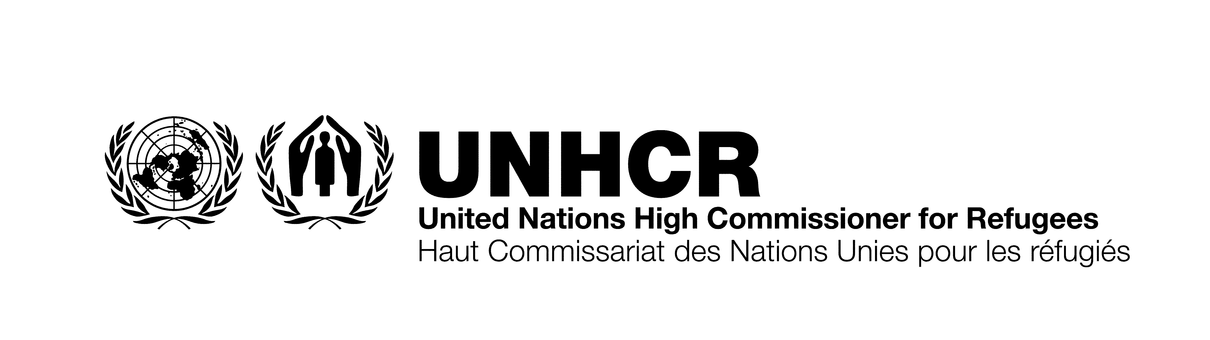

ITB No.: ITB/AZE/004/2021
SUPPLY OF SERVERS & NETWORK SECURITY SYSTEM FOR UNHCR BAKU, AZERBAIJAN

Annex B
Technical Offer Form
[To be completed by the bidder]

# | Item descriptions | Brand | Description (Manufacturer, Country of Origin, Quality Certificates, etc.)
1 | Lot 1
 | Servers
2 | Lot 2
 | Network Security Device
 | Subscriptions
 | Support
 | Installation and migration services

Please provide the following information which will be the basis of Technical Evaluation;

- Company Profile
Company profile including registration certificate and taxpayer’s certificate. Please include company structure, and list of the permanent staff who is working in the company, company assets and a brief description about the company activities and main clients. Non-submission will lead to disqualification.

- Complete details of Products
Please provide complete details of the suggested items in your offer including Brand, Manufacturer, Country of origin and quality certificates.

- Proof of prior relevant experience of supply
Evidence of the capacity and experience in similar projects (copy of the contract if available). Minimum 3 years in the market is required. To be verified by the company registration certificate.

Company Name: ------------------------------------- Authorized person: --------------------------------------

E-mail: ------------------------------------------------- Mobile Phone: ---------------------------------------------

Delivery Completion Date: Offer Validity for 30 days: Yes □ No □

Date: ----------------------- Ref: ---------------- Signature: Stamp:

